Handwritten Digit Recognition with PyTorch
A Complete Guide to the Tools, Features, Principles and Uses
No prior PyTorch or TensorFlow knowledge needed
github.com/tjsuk/HandwrittenPyTorch
Companion volume to the guide for the TensorFlow version of this project

Contents
Contents 2
1. How to use this guide 7
1.1 What this guide is for 7
1.2 This project has a twin 7
1.3 Features that help you read it 7
1.4 A quick decoder for the jargon 7
Model 8
Parameter 8
Hyperparameter 8
Tensor 8
Autograd 8
Logits 8
nn.Module 8
Training, inference, and the difference 9
Overfitting 9
1.5 What you already need to know 9
1.6 Suggested reading order 9
2. What the project is 10
2.1 The idea in one paragraph 10
2.2 Why it is written the way it is 10
2.3 What the project does not do 10
2.4 The files in the project 10
2.5 The twelve steps 11
3. Tools and setup 13
3.1 The tools the project uses 13
3.2 Installing and running the project 13
3.3 Why PyTorch is installed separately 14
3.4 Why a virtual environment is used 14
3.5 Why the last command uses a full path 14
3.6 If something goes wrong 15
4. The problem being solved 17
4.1 What the computer actually receives 17
4.2 Why you cannot just write the rules 17
4.3 Turning the problem around 17
4.4 What kind of problem this is 17
5. Why PyTorch is used 19
5.1 The job a framework does 19
5.2 The six things PyTorch gives this project 19
5.3 What PyTorch deliberately does not give you 19
5.4 What a tensor is 20
5.5 Devices, and why the code mentions cuda 21
6. The data: MNIST 22
6.1 What is in it 22
6.2 What ToTensor does, and why it matters 22
6.3 Why the data is split in two 22
6.4 Looking at the data first 23
6.5 Three things about MNIST that matter later 23
6.6 What MNIST is not 23
7. Preparing the data 24
7.1 What a pixel is here 24
7.2 Normalisation, and why it helps 24
7.3 Batching with DataLoader 24
Why batches at all 24
Why shuffle is True for training and False for testing 25
7.4 The shape at each stage 25
8. How the neural network works 26
8.1 The word neural 27
8.2 Why the model is a class 27
8.3 Inside a single neuron 27
Weights 28
Bias 28
8.4 Activation functions, and why they are needed 29
Why relu 29
8.5 The input and the flatten 29
8.6 The hidden layer 30
What it is for 30
Why 128 30
8.7 Dropout 30
8.8 The output layer, and the missing softmax 31
Why PyTorch does it this way 31
What softmax computes 31
8.9 Counting the learned numbers 32
8.10 Following one image all the way through 33
8.11 Designing your own network 34
Step 1: work out what is forced 34
Step 2: follow the conventions 34
Step 3: make the choices that are actually yours 34
Step 4: build the smallest thing that could work, then grow it 35
A worked example: designing for a different problem 35
Mistakes that catch everyone at least once 36
9. Setting up the learning 37
9.1 What the optimizer is given 37
9.2 The optimizer, and how learning actually works 37
What Adam adds 37
9.3 The loss function 38
How crossentropy behaves 38
The softmax that lives inside the loss 38
9.4 Tracking accuracy 38
10. Training the model 40
10.1 The five lines, one at a time 40
10.2 model.train() and what it actually does 41
10.3 Counting accuracy by hand 41
10.4 Epochs in detail, and the point where more becomes worse 43
What one epoch actually is 43
What happens across the epochs 43
The critical point 43
Why more training makes it worse 44
How to find the critical point 44
Why this project uses 5 45
Epochs are not the only dial 45
11. Testing the model 47
11.1 The two lines that surround everything 47
model.eval() 47
torch.no_grad() 47
11.2 What 97 to 98 percent means 47
11.3 Overfitting and underfitting 48
11.4 If your accuracy looks low 49
11.5 What one accuracy number hides 49
12. Making predictions 51
12.1 From logits to something readable 51
12.2 Reading the ten numbers 51
12.3 The three ways the project shows results 51
13. The drawing canvas 53
13.1 How the canvas is built 53
13.2 Turning a drawing into a tensor 53
13.3 The most useful lesson in the project 54
13.4 Teaching the model when it is wrong 55
Why it works 55
Why you should not trust it 55
14. Saving the trained model 56
14.1 What a state_dict is 56
14.2 Why loading takes two steps 56
14.3 Why PyTorch does it this way 56
15. Bonus: watching backpropagation happen 58
15.1 What a gradient actually is 58
15.2 How autograd works 58
15.3 The toy example, and checking it by hand 59
15.4 The same thing on the real model 60
15.5 The zero gradients, and why they are not a bug 60
15.6 Applying one real update 60
15.7 Why this section is worth your time 61
16. A better design: convolutional networks 62
16.1 The problem being fixed 62
16.2 What a convolution does 62
16.3 What pooling does 62
16.4 The bonus model 62
16.5 Working out 1600 by hand 64
16.6 What changes, and what does not 64
16.7 Comparing the two models 65
17. PyTorch and Keras side by side 66
17.1 The concept-by-concept mapping 66
17.2 What this tells you about frameworks 67
17.3 What is identical 67
18. Where this is used in the real world 68
18.1 Jobs this leads directly to 68
18.2 The step this project does not take 68
18.3 The same recipe elsewhere 68
18.4 When not to use a neural network 69
19. Limitations and risks 70
19.1 It cannot say 'I do not know' 70
19.2 Confidence is not the same as being right 70
19.3 The world changes and the model does not notice 70
19.4 There is no validation set 70
19.5 The online learning feature 70
19.6 Data and privacy 71
20. Things to try 72
21. Test yourself 74
22. Glossary 76
23. Quick reference 79
23.1 Commands 79
23.2 The code used in the project 79
Getting the data 79
Describing the network 79
Checking what you built 80
Setting up and running training 80
Working with tensors 81
Saving and loading 81
23.3 The numbers to remember 81
24. Where this information came from 82
24.1 What has been added 82

This contents list is a Word field. Open the document, click the list and press F9 to fill in the page numbers.

1. How to use this guide

1.1 What this guide is for
This guide explains a coding project that teaches a computer to read handwritten numbers. The project is a Jupyter notebook. It uses a library called PyTorch to build something called a neural network.
The guide does two things. First, it lists every tool and feature the project uses and explains what each one is for. Second, it explains the ideas behind them, so you finish understanding not just what the code does but why it is written that way, what would happen if it were written differently, and where the same techniques are used in real work.
You should not need any other source. Every new word is explained the first time it appears, and there is a full glossary at the end.

1.2 This project has a twin
There is a second project that solves exactly the same problem using a different library, TensorFlow with Keras. The notebook you are reading about here is the PyTorch counterpart, and it deliberately points out how the two approaches differ as those differences come up.
You do not need to have seen the TensorFlow one. This guide stands alone. But where PyTorch does something noticeably differently, the guide says so, because those comparisons are one of the most useful things about having both. Section 17 pulls all of them together in one place.
If you are studying both, reading the two guides side by side is worth doing. The concepts are identical. Only the typing changes, and seeing the same idea expressed two ways tends to make the idea itself much clearer.

1.3 Features that help you read it
Four kinds of box appear throughout the guide.
Key words in this section
A blue box like this lists the key words for a section before you start reading it.
Read it first, then read the section. Do not worry if the words mean nothing yet.
In short
A green box like this sums up the section in one or two sentences.
If you only remember one thing from a section, remember what is in the green box.
Check you understood
A purple box like this gives you questions to test yourself.
The answers are in the section you have just read.
An amber box gives instructions for rebuilding a diagram in another tool. Skip these unless you need to redraw the diagrams yourself.

1.4 A quick decoder for the jargon
Machine learning gives ordinary ideas frightening names, and PyTorch adds a few of its own on top. Here are the ones that trip people up, explained properly rather than in one line. Come back to this page whenever a word stops making sense.

Model
A model is a big pile of numbers plus the instructions for how to use them. That is genuinely all it is. Training a model means finding good values for the numbers. Deploying a model means copying those numbers somewhere else. There is no reasoning and no understanding in there. There is arithmetic, and there are a lot of numbers.

Parameter
A parameter is one of those numbers. The model in this project has 101,770 of them. You will also hear weight, which is a parameter that multiplies an input, and bias, which is a parameter that just gets added on. So all weights and biases are parameters, but not all parameters are weights. When someone says a language model has 70 billion parameters, they mean 70 billion adjustable numbers. Same idea, wildly different scale.

Hyperparameter
Similar word, completely different thing. A parameter is a number the computer works out for itself during training. A hyperparameter is a number you choose before training starts, and the computer never changes it. The batch size of 32, the learning rate of 0.001, the 5 epochs, the 128 hidden neurons and the dropout rate of 0.2 are all hyperparameters. Nobody calculates them. You pick them, watch what happens, and adjust.
If you remember one thing from this page, make it this. The computer tunes parameters. You tune hyperparameters. Most of the skill in this field is in the second job.

Tensor
A tensor is a grid of numbers with any number of dimensions. If you know NumPy arrays, a tensor is the same idea. PyTorch adds two things on top: a tensor can live on a graphics card instead of in ordinary memory, and it can remember how it was calculated so that training can work backwards through it later. That second ability is what section 15 is about.

Autograd
PyTorch's automatic differentiation engine. It quietly records the calculations you do with tensors, so that when you later call backward() it can work out how every number contributed to the result. It is the machinery that makes training possible, and unlike most libraries PyTorch lets you see it working.

Logits
The raw, unbounded numbers coming out of the final layer, before anything turns them into percentages. A logit can be 4.2 or minus 1.7 or anything else. This project's model outputs logits rather than probabilities, which is a deliberate PyTorch convention explained in section 9.3, and it surprises people coming from Keras.

nn.Module
The PyTorch base class that every model inherits from. Inheriting from it is what gives your model the ability to track its own parameters, move itself to a graphics card, switch between training and evaluation modes, and be saved. You write a class, it does the rest.

Training, inference, and the difference
Training is the slow, expensive bit where the model looks at labelled examples and adjusts its numbers. Inference is the fast, cheap bit where you hand it something new and get an answer. In PyTorch the difference is explicit: you call model.train() for one and model.eval() for the other, and forgetting to switch is a classic bug.

Overfitting
The single most important word in this guide. Overfitting is when a model learns the specific examples it was shown rather than the general pattern behind them. Think of someone revising by memorising last year's exam paper. Brilliant on last year's paper, hopeless on this year's. That is exactly what an overfitted model does, and sections 11 and 10.4 are largely about spotting it and preventing it.

1.5 What you already need to know
- You can read basic Python. You know what a variable, a list, a loop and a function are.
- You have met Python classes, or you are happy to be shown. PyTorch models are written as classes, so section 8.2 covers what you need.
- You have used a Jupyter notebook, or you are happy to be shown.
- You can open a terminal and type a command.
- You do not need any machine learning knowledge, and no maths beyond multiplying, adding and dividing.

1.6 Suggested reading order
If you want to | Read | Why
Get the project running | Sections 2 and 3 | The tools you need and how to install them.
Understand how it works | Sections 4 to 16, in order | Each section builds on the one before it.
Compare it with the TensorFlow version | Section 17 | Every difference between the two, in one table.
Revise for an assessment | Sections 21, 22 and 23 | Questions with answers, a glossary and the key numbers.
Look one thing up | Section 22 | The glossary.

2. What the project is
Key words in this section
Jupyter notebook: a document that mixes explanations with code you can run.
MNIST: the set of 70,000 handwritten digit images the project learns from.
Neural network: the thing the project builds, which learns to recognise the digits.
PyTorch: the library used to build and train the neural network.

2.1 The idea in one paragraph
The project teaches a computer to look at a picture of a handwritten number and say which digit it is, from 0 to 9. It learns from 70,000 example images. Once trained it gets about 97 to 98 out of every 100 new images right. You can then draw your own digit with the mouse and see whether it recognises your handwriting.

2.2 Why it is written the way it is
The notebook is a learning exercise, not a script to run. It has 40 cells that alternate between an explanation and some code. Each of the twelve steps tells you what the code does, what result to expect, and what to check if the result looks wrong.
Three features make it stand out:
- A drawing canvas in Step 11. You draw a digit with the mouse, the model tries to read it, and you can tell it when it is wrong.
- A bonus section that opens up backpropagation, checking PyTorch's maths against a hand-worked calculation.
- A second bonus section with a better kind of network you can run and compare against the first.
There is a fourth thing worth naming, which is the running comparison with Keras. Because PyTorch makes you write more of the machinery yourself, the notebook is able to point at each piece and say what the other library would have done invisibly. That makes it unusually good for understanding what a framework is actually doing for you.

2.3 What the project does not do
- It is not a finished product. There is no app, no website and no automated tests.
- It reads one digit at a time. It cannot read a whole number, a word or a page.
- It does not include a trained model. You train it yourself by running the notebook.
- It does not use a validation set, which is fine for teaching and would not be acceptable in real work. Section 19.4 explains why.

2.4 The files in the project
File | What it is
handwritten_digit_recognition_pytorch.ipynb | The whole project. 40 cells covering Steps 1 to 12, a summary with a Keras comparison table, and two bonus sections.
README.md | Instructions: what the project does, what you need, how to install it, how to run it, what to do if it goes wrong, and a set of extension exercises.
requirements.txt | Seven Python packages. Note that torch and torchvision are installed separately, for reasons covered in section 3.3.
.gitignore | Excludes the downloaded data folder and the saved model file from version control.
The trained model is not included on purpose, and neither is the MNIST data. Both appear on your own machine when you run the notebook, which keeps the repository small and means you actually train the thing yourself.

2.5 The twelve steps
Step | What happens
1 | Import torch, torchvision, matplotlib and numpy.
2 | Download and load MNIST through torchvision, already scaled to 0.0 to 1.0.
3 | Display 20 random images so you can see what the data looks like.
4 | Wrap the data in DataLoader objects that hand it out in batches of 32.
5 | Build the neural network as a Python class.
6 | Create the loss function and the optimizer.
7 | Write the training loop by hand and run it for 5 epochs.
8 | Evaluate on 10,000 unseen images, in evaluation mode.
9 | Make predictions, turning raw scores into probabilities.
10 | Show ten predictions next to the correct answers, in green or red.
11 | Draw your own digit and see if the model reads it.
12 | Save the trained weights to a .pt file.
Bonus 1 | Open up backpropagation and watch real gradients being calculated.
Bonus 2 | Build and run a convolutional network, and compare the two.
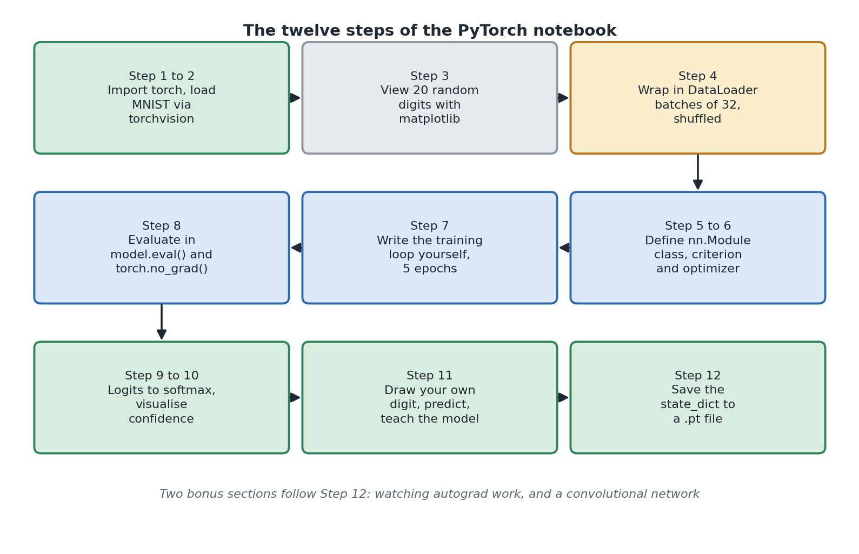
Diagram 1. The twelve steps of the project, from loading data to saving the model.
Rebuild specification, Diagram 1: notebook workflow
Type: activity or flow diagram. Layout: three rows of three rounded rectangles, arranged as a snake so flow goes left to right on row 1, right to left on row 2, then left to right on row 3.
Row 1, left to right: 'Step 1 to 2: Import torch, load MNIST via torchvision' (green fill), 'Step 3: View 20 random digits with matplotlib' (grey fill), 'Step 4: Wrap in DataLoader, batches of 32, shuffled' (amber fill).
Row 2, right to left: 'Step 5 to 6: Define nn.Module class, criterion and optimizer', 'Step 7: Write the training loop yourself, 5 epochs', 'Step 8: Evaluate in model.eval() and torch.no_grad()'. All three blue fill.
Row 3, left to right: 'Step 9 to 10: Logits to softmax, visualise confidence', 'Step 11: Draw your own digit, predict, teach the model', 'Step 12: Save the state_dict to a .pt file'. All three green fill.
Connectors: solid single headed arrows between adjacent boxes in each row; a vertical arrow down the right edge from row 1 box 3 into row 2 box 3; a vertical arrow down the left edge from row 2's leftmost box (Step 8) into row 3 box 1.
Italic grey caption underneath: 'Two bonus sections follow Step 12: watching autograd work, and a convolutional network'.
Palette: green #2F855A on #D8ECDF, blue #2B6CB0 on #DBE8F7, amber #B7791F on #FBEECD, grey #8A97A3 on #E6E9EC, text #1F2933.
In short
The project trains a neural network to recognise single handwritten digits from 0 to 9.
It is one Jupyter notebook with twelve steps plus two bonuses, written to teach you.
It is the PyTorch twin of a TensorFlow project that solves the same problem.

3. Tools and setup
Key words in this section
Library: a collection of ready-made code someone else has written for you to use.
Virtual environment (venv): a separate, private copy of Python for one project.
Kernel: the Python process that actually runs the code in your notebook.
CUDA: NVIDIA's system for running calculations on a graphics card.

3.1 The tools the project uses
Tool | What it does here | What happens without it
torch | The main library. Tensors, the nn.Module base class, the layers, the optimizer, autograd and saving. | Nothing works. This is the core.
torchvision | The companion library for images. Supplies the MNIST dataset, downloads it, and provides ToTensor() which converts and scales the images. | Step 2 fails, so there is no data.
numpy | Array handling. Picking random images to display, rounding probabilities, and the bounding box arithmetic in the drawing canvas. | Steps 3, 9, 10 and 11 fail.
matplotlib | All the pictures: the grid of sample digits, the probability bar charts, the predicted versus actual grid, and the preview of your drawing. | You can still train, but you cannot see anything.
ipycanvas | The 200 by 200 drawable canvas in Step 11, created with sync_image_data=True so Python can read back what you drew. | Step 11 fails. Everything else is fine.
ipywidgets | The Predict, Clear, Yes correct and No wrong buttons, the digit dropdown and the output areas. | Step 11 fails. Also needed by ipycanvas.
Pillow | Crops, resizes and centres your drawing so it matches the training images. | The preprocess_drawing function fails. Note it is not listed in requirements.txt.
ipykernel | Registers your virtual environment so Jupyter can run the notebook against it. | The notebook may run against a different Python that has none of the above.
Jupyter Lab or VS Code | The program you open the notebook in. | You cannot run the notebook.
Python 3.9 to 3.12 | The supported version range. | Package installation may fail or pull incompatible builds.
requirements.txt lists seven packages: torch, torchvision, matplotlib, numpy, ipykernel, ipycanvas and ipywidgets. Pillow is absent because it arrives automatically as a dependency of matplotlib and torchvision. That works, but it is a hidden assumption worth knowing about.

3.2 Installing and running the project
# 1. Create a private Python environment for this project
python -m venv .venv

# 2. Turn it on
.venv\Scripts\activate # Windows
source .venv/bin/activate # macOS or Linux

# 3. Install PyTorch from its own CPU-only index (see 3.3 below)
pip install torch torchvision \
--index-url https://download.pytorch.org/whl/cpu

# 4. Install everything else
pip install -r requirements.txt

# 5. Tell Jupyter about this environment
python -m ipykernel install --user --name=handwritten-digit-pytorch \
--display-name "Python (handwritten-digit-pytorch)"

# 6. Start Jupyter using the full path to this environment
.venv\Scripts\jupyter-lab.exe # Windows
.venv/bin/jupyter-lab # macOS or Linux
When Jupyter opens, check the kernel is set to Python (handwritten-digit-pytorch). In VS Code the kernel picker is at the top right. In Jupyter Lab it is under Kernel then Change Kernel.

3.3 Why PyTorch is installed separately
Step 3 above is the one genuinely unusual instruction, and it is worth understanding rather than copying blindly.
If you simply run pip install torch, pip fetches the default build from PyPI. That build includes CUDA support, which is the machinery for running calculations on an NVIDIA graphics card. It is enormous, often well over two gigabytes, because it bundles a large amount of GPU code.
If your machine has no NVIDIA graphics card, every byte of that is wasted. You wait for a huge download, fill up your disk, and end up running on the processor anyway. The README avoids this by pointing pip at PyTorch's own CPU-only index, which serves a much smaller build containing only what this project needs.
This is a good general lesson about dependencies. The default is not always the right choice, and a package that installs without complaint can still be the wrong build for your machine.

3.4 Why a virtual environment is used
Different projects often need different versions of the same library. Install everything into one shared Python and one project eventually breaks another. A virtual environment fixes this: the command in step 1 creates a folder called .venv holding a private copy of Python for this project alone. Everything you install goes in there and affects nothing else.
This is standard professional practice, not something specific to machine learning. It matters more than usual here because PyTorch is large and comes in several mutually incompatible builds.

3.5 Why the last command uses a full path
Step 6 starts Jupyter using the full path rather than just typing jupyter lab. Both usually work. The full path removes any doubt about which Python is starting Jupyter, and that matters more than it sounds.
Jupyter uses two separate Python processes.
Process | What it does | How it gets chosen
The kernel | Runs the code in your cells. | You pick it in the notebook, from the kernel menu.
The server | Runs the Jupyter interface itself, including the drawing widgets. | Whichever Python was used to start Jupyter.
The drawing canvas in Step 11 is handled by the server, not the kernel. So if the server started from a different Python without ipycanvas installed, the canvas will not draw even though you selected the right kernel. Using the full path guarantees the server comes from your virtual environment.
The symptom is confusing because the code does not crash. It runs, and instead of a canvas you see text such as Canvas(height=200, ...). It looks like broken code and it is actually a setup problem.

3.6 If something goes wrong
What you see | Why | What to do
Text like Canvas(height=200, ...) instead of a canvas | Jupyter started from the wrong Python, or an old server is still running in the background. | Run jupyter server list, stop any servers for this folder, then start again using the full path.
The drawing area is squashed into a small scrolling box | Jupyter Lab shrinks tall outputs by default. | Right click the output and choose Disable Scrolling for Outputs.
The torch download is enormous, or fills the disk | pip pulled the CUDA build from PyPI. | Uninstall it and reinstall using the CPU index URL from section 3.2.
ModuleNotFoundError inside the notebook | The wrong kernel is selected. | Switch to Python (handwritten-digit-pytorch). If it is missing, run the ipykernel command again.
Step 2 takes a long time the first time | torchvision is downloading MNIST into a local data folder. | Nothing. It is a few tens of megabytes and happens once.
Accuracy is far below 97 percent | Cells run out of order, or the model was rebuilt without retraining. | Restart the kernel and run every cell from the top, in order.
A NameError in Step 8 or later | You ran a cell before training finished. | Wait for Step 7 to print its finished message.
In short
Create a virtual environment, install PyTorch from the CPU index, install the rest, register the kernel, then start Jupyter using the full path.
Most problems people hit are setup problems, not code problems.
Check you understood
1. Why is torch installed with a special index URL instead of a plain pip install?
2. What is the difference between the Jupyter kernel and the Jupyter server?
3. Which step downloads MNIST, and where does it go?

4. The problem being solved
Key words in this section
Pixel: one dot in an image, stored as a number for how bright it is.
Classification: sorting something into one of a fixed set of categories.
Supervised learning: learning from examples that come with the correct answers.

4.1 What the computer actually receives
When you look at a handwritten 3 you see a curved stroke, instantly and without thinking. The computer does not. It receives 784 numbers, each one the brightness of a single pixel. Nothing tells it which pixels are next to each other or that they form a shape. It has 784 numbers and it must decide which of ten digits they represent.
Keep this in mind throughout. Everything the model eventually knows about shapes it works out for itself, from thousands of examples.

4.2 Why you cannot just write the rules
The obvious approach is to write rules. Try it for a 7. Perhaps: a horizontal line across the top joined to a diagonal going down and left. Now the exceptions arrive.
- A 7 with a line through the middle, normal across much of Europe.
- A 7 whose top line is very short, so it looks like a 1.
- A 7 with a curved diagonal rather than a straight one.
- A 7 written on a slant, or in a hurry, or so thickly the corner fills in.
Every rule needs an exception and every exception needs its own. Before long the rules for 7 start clashing with the rules for 1 and 9. The dataset holds 70,000 examples of how differently people write ten symbols, and no sensible set of hand-written rules covers that.

4.3 Turning the problem around
Approach | You give the computer | The computer gives you
Normal programming | Rules, and some data | Answers
Machine learning | Data, and the correct answers | Rules, in the form of learned numbers
This is supervised learning. Supervised means every example comes with the right answer attached, and MNIST does exactly that. The rules the computer produces are not sentences you can read. They are 101,770 numbers. That is a genuine trade-off: the approach works where writing rules cannot, but you lose the ability to read the logic and explain any single decision. Section 19 returns to this.

4.4 What kind of problem this is
Type of problem | The question it answers | Example | Is this it?
Binary classification | Is it A or B? | Is this email spam? | No
Multi-class classification | Which one of several categories is it? | Which of the ten digits is this? | Yes
Multi-label classification | Which of these apply, possibly several? | Which objects are in this photo? | No
Regression | What number is it? | What will this house sell for? | No
Object detection | What is in the picture and where? | Find every car in this street scene | No
Multi-class classification with ten categories that cannot overlap. An image is a 4 or a 9, never both. That single fact decides the size of the last layer and which loss function is correct, as section 9 explains. Work out the type of problem first, then build the model to match.
In short
Hand-written rules cannot cope with how much handwriting varies.
Instead you supply labelled examples and the computer works out the rules itself.
This is multi-class classification with ten categories.

5. Why PyTorch is used
Key words in this section
Framework: a large library you build a whole program on top of.
Autograd: the part of PyTorch that works out gradients automatically.
Device: where a tensor lives and where its maths happens, either the CPU or a GPU.

5.1 The job a framework does
Getting a computer to learn rules from data sounds neat. Actually doing it needs a lot of code. You would have to store the model as adjustable numbers, push thousands of images through it quickly, measure how wrong the answers were, work out how each individual number contributed to that wrongness, adjust every number a little, repeat thousands of times, and then save the result.
From scratch that is thousands of lines of tricky mathematical code, most of it easy to get subtly wrong. A framework exists so that none of it appears in your project.

5.2 The six things PyTorch gives this project
What it gives you | In plain terms | Where the project uses it
Tensors | Fast multi-dimensional arrays that can also track how they were calculated. | Every image, every weight, every prediction in the notebook is a tensor.
The dataset | Popular datasets available through torchvision, downloading themselves on first use. | torchvision.datasets.MNIST fetches all 70,000 images into a local data folder.
Ready-made layers | Building blocks you assemble inside a class. | nn.Flatten, nn.Linear, nn.ReLU and nn.Dropout in the main model. nn.Conv2d and nn.MaxPool2d in the bonus.
Autograd | It works out how to improve each of the 101,770 numbers, automatically. | loss.backward(). This is the hardest part of machine learning and you get it in one line.
Optimisers | Tested implementations of the algorithms that apply those adjustments. | torch.optim.Adam, created once in Step 6 and called every batch in Step 7.
Saving | A standard way to write learned weights to disk. | torch.save(model.state_dict(), ...). Note it saves the numbers only, as section 14 explains.

5.3 What PyTorch deliberately does not give you
This is the interesting part, and it is the main difference from Keras. PyTorch does not give you a training loop, does not batch your data for you, and does not track accuracy on your behalf. You write all three.
That sounds like a downside and it is a real trade. More typing, more places to make mistakes, four common bugs that Keras users never meet. But you also see exactly what is happening at every step, which is why PyTorch is so often the choice for research and for anything unusual: when the standard training loop is not what you need, you can simply write a different one.
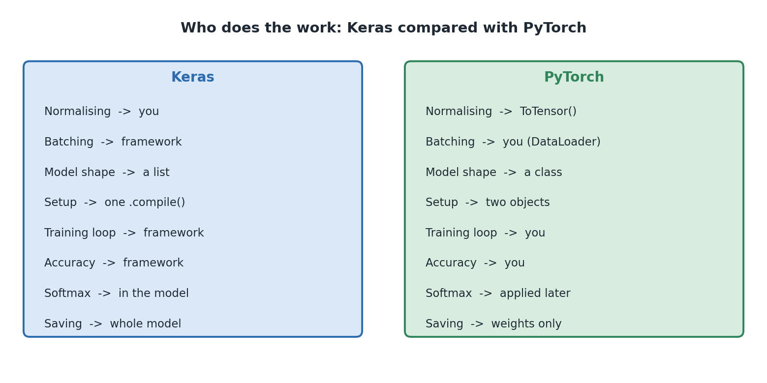
Diagram 2. Which library does which job. Anything marked 'you' is something you write.
Rebuild specification, Diagram 2: who does the work
Type: two-column comparison panel. Two large rounded rectangles side by side, equal size, no connectors.
Left panel: pale blue fill #DBE8F7, blue border #2B6CB0, heading in bold blue at the top: 'Keras'.
Right panel: pale green fill #D8ECDF, green border #2F855A, heading in bold green at the top: 'PyTorch'.
Each panel holds eight left-aligned lines, evenly spaced, in matching order so the rows line up across the two panels.
Left panel lines: 'Normalising -> you', 'Batching -> framework', 'Model shape -> a list', 'Setup -> one .compile()', 'Training loop -> framework', 'Accuracy -> framework', 'Softmax -> in the model', 'Saving -> whole model'.
Right panel lines: 'Normalising -> ToTensor()', 'Batching -> you (DataLoader)', 'Model shape -> a class', 'Setup -> two objects', 'Training loop -> you', 'Accuracy -> you', 'Softmax -> applied later', 'Saving -> weights only'.
Title above both: 'Who does the work: Keras compared with PyTorch'.
Notice that it is not simply that PyTorch makes you do more. Normalising is automatic in PyTorch and manual in Keras. The split of responsibilities is genuinely different rather than uniformly heavier.

5.4 What a tensor is
A tensor is a grid of numbers with any number of dimensions. Error messages talk about shapes constantly, so it is worth knowing the vocabulary.
Dimensions | Name | Example from this project
0 | A single number | The loss for one batch, or the test accuracy
1 | A list | The ten scores for one image
2 | A grid | The weight matrix of the hidden layer, shaped (128, 784)
3 | A stack of grids | One image as loaded, shaped (1, 28, 28): channel, height, width
4 | A batch of those | One batch from the DataLoader, shaped (32, 1, 28, 28)
Two habits of PyTorch catch people out here. It puts the channel dimension before height and width, so images are (channels, height, width) rather than the (height, width, channels) that TensorFlow uses. And a Linear layer's weight matrix is stored as (outputs, inputs), which is the reverse of what you might expect. Both matter in section 15, and the notebook flags the second one explicitly.

5.5 Devices, and why the code mentions cuda
device = torch.device("cuda" if torch.cuda.is_available() else "cpu")
model.to(device)
In PyTorch, every tensor lives somewhere: on the CPU, in ordinary memory, or on a GPU, in the graphics card's memory. Maths only works between tensors on the same device, which is why the training loop moves each batch with images.to(device).
These two lines mean the notebook uses a graphics card if one is available and falls back to the processor otherwise, with no code changes needed either way. On a typical laptop it prints 'Using device: cpu' and trains in well under a minute, which is entirely fine for a dataset this size.
This is one place PyTorch has a straightforward advantage over TensorFlow on Windows, where native GPU support was dropped after version 2.10. PyTorch's Windows GPU support works normally, so a machine with an NVIDIA card and a CUDA build of PyTorch will use it here automatically.
In short
PyTorch supplies tensors, layers, autograd, optimisers and saving.
It deliberately leaves you to write the training loop, the batching and the accuracy tracking.
More typing, more visibility. That trade is the whole character of the library.
Check you understood
1. Name two things PyTorch does for you and two things it leaves to you.
2. What shape is a single MNIST image in this project, and what does each number mean?
3. What do the two device lines in Step 7 achieve?

6. The data: MNIST
Key words in this section
Dataset: a collection of examples used to train or test a model.
Label: the correct answer attached to an example.
Training set and test set: examples used for learning, and examples held back for checking.
Transform: something applied to each image as it is loaded.

6.1 What is in it
MNIST contains 70,000 pictures of handwritten digits. Each is 28 pixels by 28 pixels in shades of grey, and each comes with a label saying which digit it shows. 60,000 are for training and 10,000 are held back for testing.
transform = transforms.ToTensor()

train_dataset = torchvision.datasets.MNIST(root="./data", train=True,
download=True, transform=transform)
test_dataset = torchvision.datasets.MNIST(root="./data", train=False,
download=True, transform=transform)
The first time you run this, torchvision downloads MNIST into a local data folder, a few tens of megabytes. After that it uses the local copy. The train=True and train=False arguments choose which half you get.

6.2 What ToTensor does, and why it matters
ToTensor is a transform, meaning it is applied to every image as it is loaded. It does two jobs at once, and the second one is easy to miss.
- It converts the image into a PyTorch tensor shaped (1, 28, 28): one colour channel, 28 rows, 28 columns.
- It scales the pixel values from whole numbers between 0 and 255 down to decimals between 0.0 and 1.0.
That second job is normalisation, and it is important enough that section 7 covers why. The thing to notice here is that PyTorch does it for you automatically, whereas the TensorFlow version of this project has an explicit step dividing by 255.
Automatic is convenient and it is also a small risk. Because you never typed the division, it is easy to forget that it happened, and then be baffled when your own images produce nonsense. Section 13 shows the canvas code carefully reproducing the same scaling by hand, precisely because the transform is not applied there.
The notebook prints the shape and value range of one image immediately after loading. Get into that habit. Confirming the shape of your data before using it catches a whole family of later confusion.

6.3 Why the data is split in two
If you test a model on pictures it already learned from, it might simply be remembering them. That tells you nothing useful. What you want to know is whether it can handle handwriting it has never seen.
So 10,000 pictures are set aside at the start and never shown during training. They are used once, at the end, to score the model. That score is the honest one.
Decide the split at the beginning and never cross it. Using test data to help you make choices is a quiet way to end up with results that look excellent and then fail in the real world.

6.4 Looking at the data first
Step 3 shows 20 random training images in a grid with their labels, picking different ones each run. It trains nothing and improves no score, and it is one of the most valuable steps in the notebook.
Looking at real examples shows you how much the handwriting varies, how thick the strokes are, and how some digits are genuinely hard to read even for you. It also catches obvious data problems, such as labels not matching pictures.
One PyTorch detail appears here: the code calls image.squeeze().numpy() before plotting. squeeze() drops the size-one channel dimension, turning (1, 28, 28) into (28, 28), and .numpy() converts the tensor into the plain array matplotlib expects. Small, but it is the kind of shape juggling PyTorch asks of you regularly.

6.5 Three things about MNIST that matter later
- The digits are white on a black background. That is why the drawing canvas is black with a white pen.
- The digits are all a similar size and sit in the middle with a gap around the edge. That is why the canvas code crops and re-centres your drawing rather than just shrinking the whole canvas.
- The strokes are fairly thick. That is why the canvas uses a thick pen and the README tells you to draw big and bold.
The rule behind all three: whatever the training pictures look like, anything you show the model later has to look the same. Section 13 turns this into the single most useful lesson in the project.

6.6 What MNIST is not
- Every picture holds exactly one digit, already cut out. Real documents do not.
- Every digit is neatly sized and centred. Real handwriting is not.
- The handwriting came from one group of people decades ago. Digits are written differently in different countries.
- The pictures are clean. No smudges, no lined paper, no shadows.
- Every input is guaranteed to be one of the ten digits. The model has no way to say this is not a digit at all.
In short
70,000 labelled 28 by 28 greyscale images, split 60,000 for training and 10,000 for testing.
ToTensor() converts each image to a (1, 28, 28) tensor and scales it to 0.0 to 1.0 automatically.
MNIST digits are white on black, centred and thick. Anything you show the model later must match.
Check you understood
1. What two jobs does ToTensor() do?
2. Why must the test images never be used during training?
3. What does the 1 mean in the shape (1, 28, 28)?

7. Preparing the data
Key words in this section
Normalisation: scaling numbers into a small, consistent range.
Batch: a small group of images processed together.
DataLoader: the PyTorch object that hands out a dataset in batches.
Shuffling: mixing the order of the training examples.

7.1 What a pixel is here
Each pixel is one number for brightness. In the original files that is a whole number from 0 for black to 255 for white, with shades of grey in between. A 28 by 28 picture is therefore 784 numbers, and that is the entire picture as far as the computer is concerned.

7.2 Normalisation, and why it helps
ToTensor has already divided everything by 255, so the values arrive between 0.0 and 1.0. Since you never typed that division, it is worth understanding what it bought you.
A neuron multiplies each input by a number and adds them all up. With 784 inputs each up to 255, those totals get very large before any learning has happened. Large, uneven numbers make training unstable: some adjustments come out far too big and others far too small, and the whole process becomes fragile and slow.
Scaling everything into the same small range makes the maths behave. Training gets faster and, more importantly, more reliable.
The rule that follows is the one that catches people out: whatever was done to the training data must be done to anything else the model sees. The transform only applies to images loaded through the dataset. Your own drawing in Step 11 is not, so that code divides by 255 by hand to match. Miss that and the model appears to work while producing nonsense.

7.3 Batching with DataLoader
BATCH_SIZE = 32

train_loader = DataLoader(train_dataset, batch_size=BATCH_SIZE, shuffle=True)
test_loader = DataLoader(test_dataset, batch_size=BATCH_SIZE, shuffle=False)
A DataLoader wraps a dataset and hands it out in batches. Loop over it and you get tuples of images and labels, 32 at a time. With 60,000 training images that is 1,875 batches per pass.
Keras does this invisibly inside fit, which is why the TensorFlow version of this project has no equivalent step. In PyTorch it is an object you create, which means you can see it, change it and reason about it.

Why batches at all
Two extremes show why. Update the weights after every single image and the adjustments are wildly erratic, because one image is not representative of anything. Update only after all 60,000 and you get one very careful adjustment per pass, which is far too few to get anywhere. Batches of 32 sit in between: each adjustment is based on a reasonable sample, and 32 images can be processed almost as quickly as one.
There is a bonus to the wobbliness. Because each batch is a slightly different sample, the adjustments jiggle rather than heading in a dead straight line, and that jiggle helps the search avoid settling in the first mediocre place it finds. Noise as a feature rather than a bug.

Why shuffle is True for training and False for testing
This small difference is worth explaining because it is easy to copy without thinking.
- For training, shuffle=True reorders the data every pass. Without it, the model would see the examples in the same order every epoch, and could pick up on that order rather than on the digits. Shuffling also means each batch is a fairer mixture of digits.
- For testing, shuffle=False keeps the order fixed. Nothing is being learned, so shuffling would gain nothing, and a fixed order means results line up predictably with the labels when you go to display them.

7.4 The shape at each stage
Stage | Shape | What it is
One image from the dataset | (1, 28, 28) | Channel, height, width. Values 0.0 to 1.0
One batch from the DataLoader | (32, 1, 28, 28) | 32 images, each with a channel
After nn.Flatten | (32, 784) | Each image collapsed to a flat list
After the hidden layer | (32, 128) | 128 learned features per image
After the output layer | (32, 10) | Ten raw scores per image, not yet probabilities
After softmax | (32, 10) | Ten probabilities per image, each row adding to 1.0
In short
ToTensor already scaled the pixels to 0.0 to 1.0. That is normalisation, and it makes training work properly.
DataLoader hands the data out in batches of 32, shuffled for training and not for testing.
Keras does batching invisibly. In PyTorch it is an object you create yourself.

8. How the neural network works
Key words in this section
Layer: one stage of the network that takes numbers in and passes numbers out.
Neuron: one small calculator inside a layer.
Weight: a learned number saying how much one input matters.
Bias: one extra learned number added on at the end.
Activation function: a simple function applied to a neuron's result.
Logits: the raw, unbounded scores the last layer produces.
This is the most important section in the guide. Take it slowly. Everything refers to the actual model the project builds in Step 5.
class HandwrittenDigitClassifier(nn.Module):
def __init__(self):
super().__init__()
self.flatten = nn.Flatten()
self.hidden = nn.Linear(28 * 28, 128)
self.relu = nn.ReLU()
self.dropout = nn.Dropout(0.2)
self.output = nn.Linear(128, 10)

def forward(self, x):
x = self.flatten(x)
x = self.hidden(x)
x = self.relu(x)
x = self.dropout(x)
x = self.output(x) # raw logits, no softmax here
return x
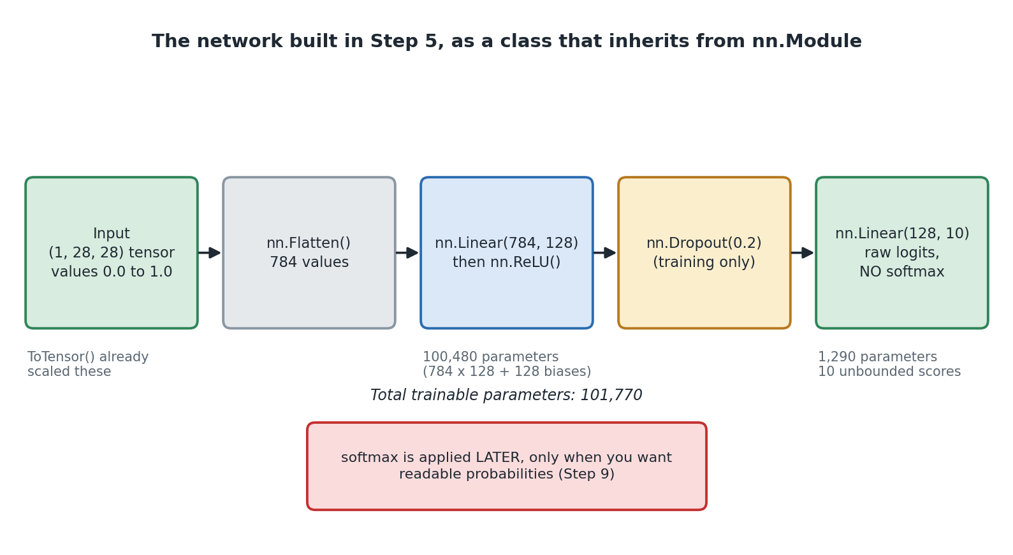
Diagram 3. The five stages of the network, left to right.
Rebuild specification, Diagram 3: layer architecture
Type: block diagram. Five rounded rectangles in a single horizontal row, equal size, evenly spaced, joined left to right by solid single headed arrows.
Box 1 (green): 'Input / (1, 28, 28) tensor / values 0.0 to 1.0'. Small grey note beneath: 'ToTensor() already scaled these'.
Box 2 (grey): 'nn.Flatten() / 784 values'.
Box 3 (blue): 'nn.Linear(784, 128) / then nn.ReLU()'. Grey note beneath: '100,480 parameters (784 x 128 + 128 biases)'.
Box 4 (amber): 'nn.Dropout(0.2) / (training only)'.
Box 5 (green): 'nn.Linear(128, 10) / raw logits, / NO softmax'. Grey note beneath: '1,290 parameters. 10 unbounded scores'.
Italic line centred below the row: 'Total trainable parameters: 101,770'.
Beneath that, a separate red-bordered box on pale red fill, centred: 'softmax is applied LATER, only when you want readable probabilities (Step 9)'.
Title above: 'The network built in Step 5, as a class that inherits from nn.Module'.
Palette: green #2F855A on #D8ECDF, blue #2B6CB0 on #DBE8F7, amber #B7791F on #FBEECD, grey #8A97A3 on #E6E9EC, red #C53030 on #FBDCDC.

8.1 The word neural
These are called neural networks because of a loose comparison with the brain. A brain cell receives signals from many others and fires when the total is big enough. An artificial neuron receives many numbers, combines them, and produces an output depending on whether the total is big enough.
That is where the comparison ends. Artificial neurons sit in neat fixed rows, all do the same simple sum, and are trained by a method with no biological counterpart. Treat the name as history rather than description.

8.2 Why the model is a class
This is the first big structural difference from Keras, where a model is a list of layers. In PyTorch it is a class, and it is worth understanding what each part is doing rather than treating it as boilerplate.
Part of the class | What it is for
class ... (nn.Module) | Inherits from PyTorch's base class for models. This is what gives the model the ability to track its own parameters, move to a GPU, switch between training and evaluation modes, and be saved.
__init__ | Runs once when you create the model. It creates the layers and stores them on self. Creating a layer here is what makes its weights exist and get registered as parameters.
super().__init__() | Calls nn.Module's own setup. Miss this line and nothing works, because the machinery that tracks your layers never gets initialised.
forward | Runs every time you pass data in. It says what happens to the data, in what order. This is the actual shape of the network.
The split is the key idea. __init__ says what parts exist. forward says how data flows through them. Keras merges the two into a single list, which is shorter to write and less flexible.
That flexibility is not hypothetical. Because forward is ordinary Python, you can put an if statement in it, use a layer twice, skip a layer, or split the data down two paths and recombine it. A list cannot express any of that. For this project you never need it, and for research it is the whole point.
You call the model as model(images), not model.forward(images). Both appear to work, but the first is correct: it goes through nn.Module's own call machinery, which does necessary bookkeeping around your forward method. Calling forward directly skips it.

8.3 Inside a single neuron
Every neuron in a Linear layer holds one weight per input, plus one bias. It does this:
1. Multiply each input by that input's weight.
2. Add all those results together.
3. Add the bias.
4. Pass the total on, usually into an activation function.
total = (w1 * x1) + (w2 * x2) + ... + (w784 * x784) + bias
output = relu(total)
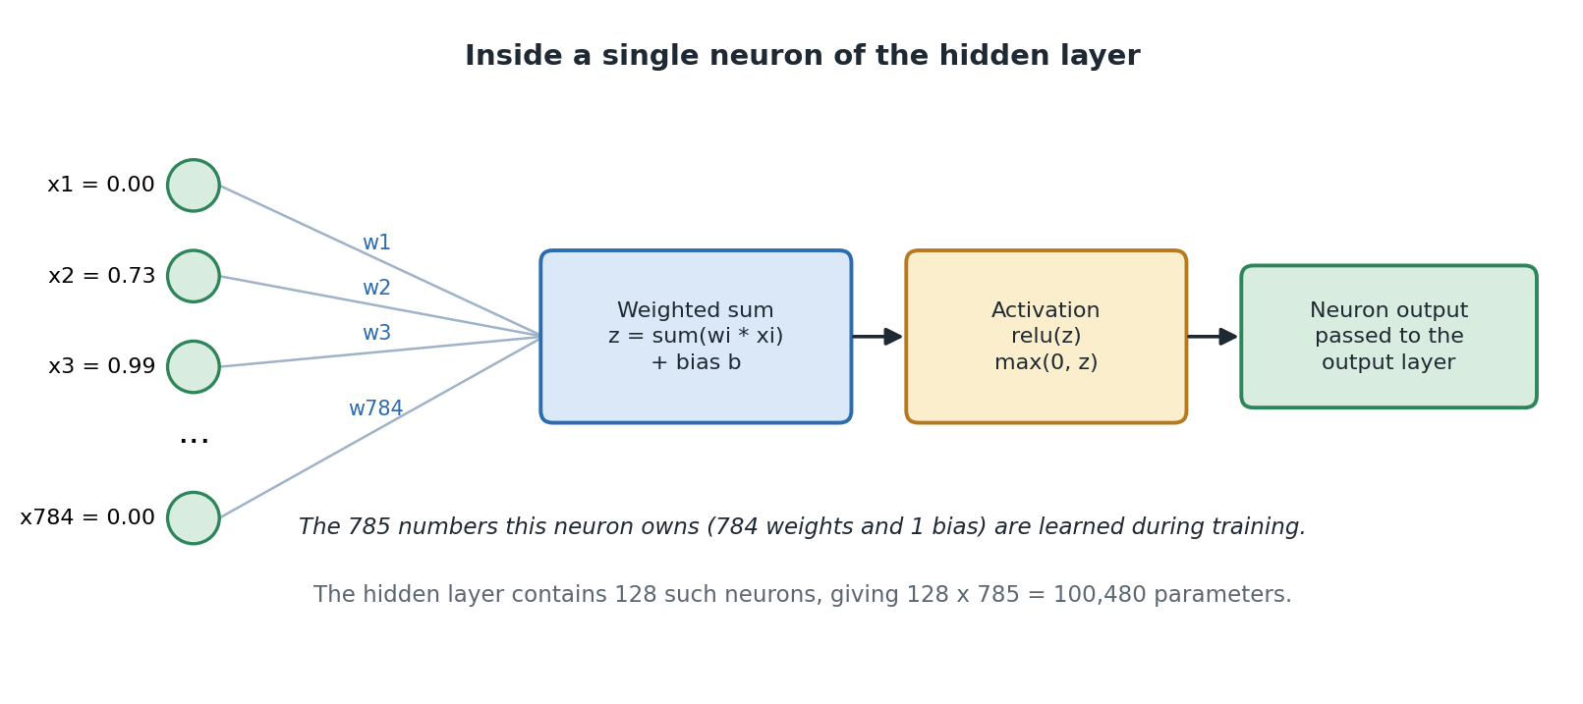
Diagram 4. One neuron: a weighted sum, then an activation function.
Rebuild specification, Diagram 4: inside a single neuron
Type: detail diagram. Left group: four small green circles stacked vertically, labelled to their left as 'x1 = 0.00', 'x2 = 0.73', 'x3 = 0.99', vertical ellipsis, 'x784 = 0.00'.
Each circle connects by a thin light blue-grey line converging on the left edge of a single box. Label each connector along its length in blue: w1, w2, w3, w784.
Box A (blue, centre left): 'Weighted sum / z = sum(wi * xi) / + bias b'.
Arrow right into Box B (amber): 'Activation / relu(z) / max(0, z)'.
Arrow right into Box C (green): 'Neuron output / passed to the output layer'.
Title above: 'Inside a single neuron of the hidden layer'. Italic caption below: 'The 785 numbers this neuron owns (784 weights and 1 bias) are learned during training.' Grey caption beneath: 'The hidden layer contains 128 such neurons, giving 128 x 785 = 100,480 parameters.'
Palette as Diagram 3.

Weights
A weight says how much one particular pixel matters to one particular neuron.
- A big positive weight means: when this pixel is bright, push my output up.
- A big negative weight means: when this pixel is bright, push my output down.
- A weight near zero means: I do not care about this pixel.
The weights are what the network learns. Nobody sets them. Training changes them until the answers come out right. A trained neuron is therefore a detector for some pattern of light and dark pixels, and nobody chose which pattern.

Bias
The bias is one extra number added at the end, the same every time regardless of input. It shifts how easily the neuron switches on. Without it, a neuron receiving all zeros would always output zero, which removes useful flexibility for no reason.
In PyTorch, nn.Linear(784, 128) creates both the weights and the biases for you, and stores the weight matrix shaped (128, 784), that is outputs by inputs. This is the reverse of what you might expect and the reverse of Keras. It matters in section 15, and the notebook flags it there.

8.4 Activation functions, and why they are needed
Suppose there were no activation functions and every layer just did the weighted sum. Adding up weighted sums gives you another weighted sum. So a hundred stacked layers would do exactly the same job as one layer, and the network could only ever learn simple straight-line relationships. Nowhere near enough to tell a 3 from an 8.
An activation function is a small bend placed between layers. That bend is what stops everything collapsing into one layer, and it is why extra layers buy you anything at all.
Function | What it does | Where it is used | Here?
nn.ReLU | If the number is positive keep it, if negative make it 0. | The normal choice for hidden layers. | Yes, hidden layer
softmax | Turns a set of scores into percentages adding up to 1. | Turning final scores into readable confidence. | Yes, but outside the model
sigmoid | Squashes any number into 0 to 1, on its own. | Yes or no answers, or several answers at once. | No
tanh | Squashes any number into minus 1 to 1. | Common in older networks before relu took over. | No
none | Leaves the number alone. | When the answer is an unbounded number, like a price. | Yes, on the output layer

Why relu
relu is almost embarrassingly simple: negative becomes zero, positive stays put. It became standard for three reasons. It is extremely fast, being one comparison. It does not flatten out for large values, so learning keeps progressing instead of stalling. And because roughly half the neurons output exactly zero at any moment, networks using it tend to generalise better.

8.5 The input and the flatten
Each image arrives shaped (1, 28, 28). nn.Flatten collapses that into a flat list of 784 numbers, because a Linear layer expects a flat list rather than a grid. Flatten learns nothing. It only rearranges.
There is a real cost. Once flattened, the information about which pixels were next to each other is gone. Two pixels that sat one above the other are now 28 places apart in a list, and nothing tells the network that means anything.
Here is a striking way to put it. If you shuffled the 784 positions into a random order, and used the same shuffle for every image, the network would learn just as well. It has no idea the picture is a picture. This is exactly what the convolutional network in section 16 fixes.
The size of the input is decided by the data, not by you. 28 times 28 is 784, always. If the pictures were 64 by 64, it would be 4,096.

8.6 The hidden layer
nn.Linear(784, 128) creates a fully connected layer of 128 neurons. Fully connected means every one of the 128 neurons sees all 784 inputs, so there are 784 times 128 individual weights between the two layers.
It is called hidden because it is neither the data you supply nor the answer you read out. It is the network's own private working-out, and there is no reason any single one of its numbers should mean anything a human would name.

What it is for
Think of it as squeezing 784 raw pixels down into 128 useful summaries. Each summary is some combination of pixels that turned out to help tell digits apart. The output layer then works from those 128 summaries rather than from raw pixels.
This is the whole idea behind having layers. Rather than jumping straight from pixels to answers, the job is split: one layer finds useful descriptions, the next uses them to decide. More layers means more abstract descriptions, which is what deep means in deep learning.

Why 128
Nobody calculated 128. It is a choice, and it acts as a dial for how much the network can learn.
Setting | What happens | How you spot it
Too small, say 8 | Not enough room to learn the variety in the data. | Both training and test scores stall at a low level.
About right, say 128 | Enough room for general patterns without excessive freedom. | Both scores high and close together.
Too big, say 4096 | More room than the job needs. Slower, and more likely to memorise. | Training score almost perfect, test score clearly lower.

8.7 Dropout
nn.Dropout(0.2) sits between the hidden layer and the output layer. While training it randomly switches off 20 percent of the hidden neurons on each pass, a different 20 percent each time.
Why deliberately break your own network? Because it stops any one neuron becoming essential. If the answer depends on one neuron, the network has found a fragile shortcut rather than a general pattern. Since any neuron might vanish at any moment, the network has to spread what it knows across many of them.
Two things people get wrong:
- It only happens during training. In PyTorch this is not automatic in the way beginners assume: dropout follows the mode you set with model.train() and model.eval(). Section 11.1 covers why forgetting to switch is a classic bug.
- It learns nothing. It has no weights and no biases at all. It is a behaviour, not a store of numbers.
0.2 is a gentle setting. The bonus CNN uses 0.3. Above about 0.5 it usually does more harm than good, because too much of the network is missing on each pass for it to learn efficiently.

8.8 The output layer, and the missing softmax
The output layer is nn.Linear(128, 10), one output per digit. Ten possible answers means ten outputs, and unlike the hidden layer size that is not a choice.
Now the part that surprises people. There is no softmax. The model's final line is a comment saying raw logits, and the numbers coming out can be anything at all: 4.2, minus 1.7, 0.03. They are not probabilities and they do not add up to anything in particular.

Why PyTorch does it this way
The loss function used in Step 6, nn.CrossEntropyLoss, applies softmax internally as part of its own calculation. If the model applied softmax too, it would be applied twice, which is wrong and produces a model that trains poorly.
There is also a numerical reason. Combining softmax and the loss into one operation lets PyTorch use a more stable formula than doing them separately, avoiding very large and very small numbers that computers handle badly.
So the rule in PyTorch is: your model outputs logits, your loss function expects logits, and you apply softmax by hand only when you want numbers a human can read. That is exactly what Step 9 does.
# Step 9: only now do we convert scores into probabilities
logits = model(x_test_tensor.to(device))
predictions = torch.softmax(logits, dim=1).cpu().numpy()
This is one of the biggest practical differences from Keras, where the model itself ends in activation="softmax" and outputs probabilities directly. Neither is wrong. Copying a model between the two libraries without noticing is, though, and it is a common source of confusion.

What softmax computes
Softmax raises each score to a power to make it positive and exaggerate differences, then divides each by the total so they add up to 1. Here it is with three scores rather than ten.
# example only, not project code
raw scores [1.0, 4.0, 0.5 ]
after exponent [2.72, 54.60, 1.65]
total 58.97
after dividing [0.046, 0.926, 0.028] adds up to 1.0
Because they add up to 1 you can read them as confidence. It also builds in the rule that only one answer can be right: if one digit's number rises, the others must fall.
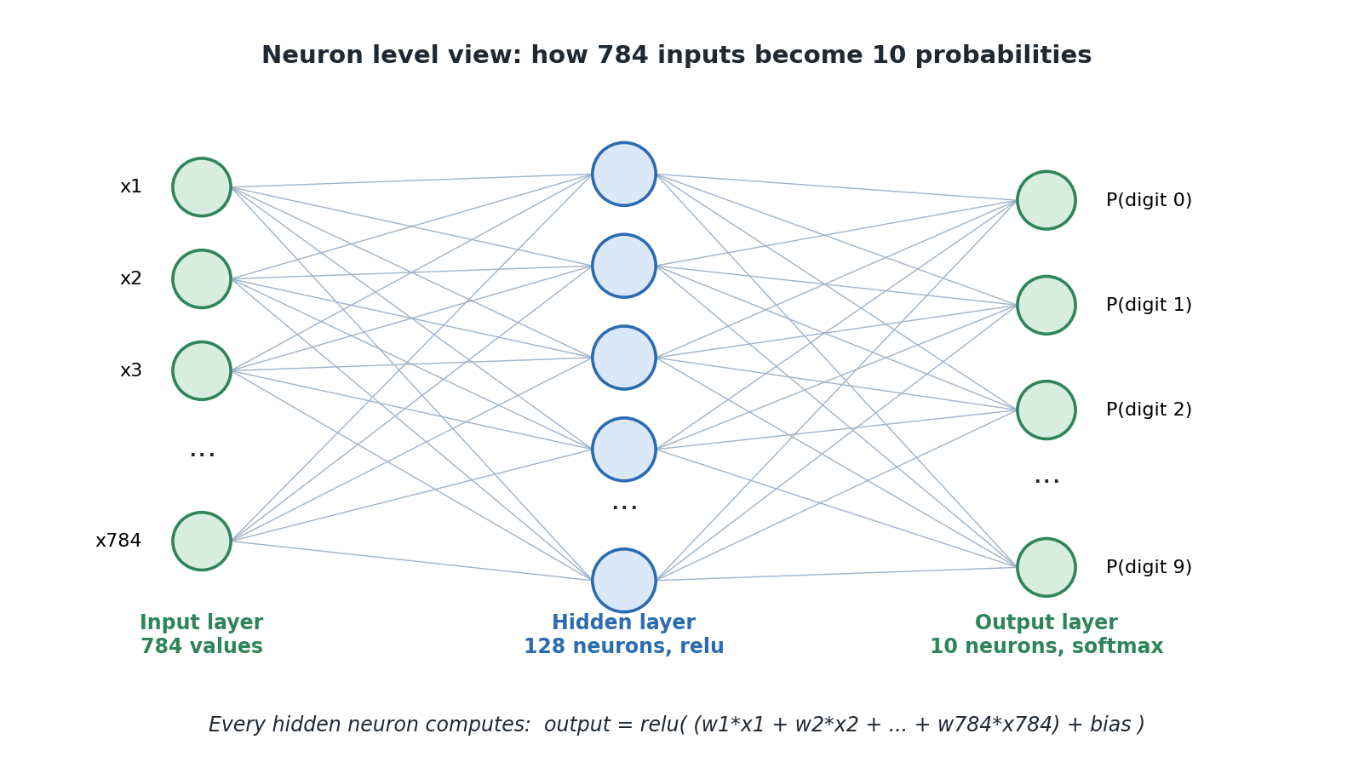
Diagram 5. The three layers, showing that every neuron connects to every neuron in the next layer.
Rebuild specification, Diagram 5: neuron level view
Type: classic three layer neural network diagram. Three vertical columns of circles, evenly spaced horizontally, with thin straight lines connecting every circle to every circle in the adjacent column.
Left column (green circles, 4 shown): labelled to the left as x1, x2, x3, vertical ellipsis, x784. Column caption beneath in bold green: 'Input layer / 784 values'.
Middle column (blue circles, 5 shown): no individual labels, vertical ellipsis between the fourth and fifth. Column caption beneath in bold blue: 'Hidden layer / 128 neurons, relu'.
Right column (green circles, 4 shown): labelled to the right as P(digit 0), P(digit 1), P(digit 2), vertical ellipsis, P(digit 9). Column caption beneath in bold green: 'Output layer / 10 neurons, softmax'.
Connector lines: light blue-grey #9FB3C8, hairline weight, drawn behind the circles.
Title above: 'Neuron level view: how 784 inputs become 10 probabilities'. Italic footer: 'Every hidden neuron computes: output = relu( (w1*x1 + w2*x2 + ... + w784*x784) + bias )'.
Note when rebuilding: the ellipses are essential, since drawing all 784, 128 and 10 nodes is unreadable. Note also that in this PyTorch project the softmax shown on the right happens outside the model, in Step 9, not inside the output layer.

8.9 Counting the learned numbers
Keras prints a formatted summary table. PyTorch has no built-in equivalent, so the notebook does two things: it prints the model, which lists the layers, and it totals the parameters by hand.
print(model)

total_params = sum(p.numel() for p in model.parameters())
print(f"Total parameters: {total_params:,}")
model.parameters() returns every learnable tensor in the model, and numel() gives the number of individual values in each one. Summing them gives the total. The fact that this works at all is thanks to nn.Module: because you assigned the layers to self in __init__, PyTorch knows about all of them.
Layer | Numbers it learns | How that is worked out
nn.Flatten | 0 | It only rearranges.
nn.Linear(784, 128) | 100,480 | 784 inputs x 128 neurons = 100,352 weights, plus 128 biases.
nn.ReLU | 0 | A fixed function with nothing to learn.
nn.Dropout(0.2) | 0 | A behaviour, not stored numbers.
nn.Linear(128, 10) | 1,290 | 128 x 10 = 1,280 weights, plus 10 biases.
Total | 101,770
101,770 is exactly the same as the TensorFlow version, because it is exactly the same architecture. The libraries differ; the maths does not. Confirming that for yourself is a satisfying way to prove the two projects really are doing the same thing.
Notice that almost 99 percent of the numbers are in the first Linear layer, simply because 784 times 128 is a lot of connections. That is normal for this kind of network and one reason the convolutional version in section 16 is more efficient.

8.10 Following one image all the way through
1. An image arrives shaped (1, 28, 28), values between 0.0 and 1.0.
2. nn.Flatten turns it into 784 numbers. Nothing is calculated.
3. Each of the 128 hidden neurons multiplies all 784 numbers by its own weights, adds them, adds its bias. The layer produces 128 numbers.
4. nn.ReLU turns any negatives among those into zero.
5. Dropout does nothing here, because this is a prediction and not training.
6. Each of the 10 output neurons multiplies those 128 numbers by its own weights, adds them and adds its bias. The layer produces 10 raw logits.
7. The model returns those logits. Softmax and argmax happen outside, in Step 9.
That is 101,632 multiplications for one image. PyTorch does them as two large block operations, which is why a batch of thousands can be handled in a fraction of a second.

8.11 Designing your own network
You now know what every layer does and why it is there. Could you build one yourself, for a different problem, without copying somebody else's code? Yes, and this section is about how.
The trick is realising most of the design is not up to you. Some parts are forced by the problem, some are conventions you follow until you have a reason not to, and only a handful are genuinely open choices.

Step 1: work out what is forced
What | Decided by | In this project
The size of the input | The shape of your data. Count the numbers in one example. | 1 x 28 x 28, flattened to 784
The number of outputs | How many possible answers there are. | 10, one per digit
The loss function | What kind of question you are asking. | nn.CrossEntropyLoss, because it is one answer out of ten
That third row is the one people get wrong. Find your row below, use that pairing, and stop thinking about it. Note that in PyTorch the choice of loss also decides whether your model should end in an activation at all.
Your question | Final layer | Loss function
One answer out of several (this project) | nn.Linear(n, categories), no activation | nn.CrossEntropyLoss, which applies softmax itself
Yes or no | nn.Linear(n, 1), no activation | nn.BCEWithLogitsLoss, which applies sigmoid itself
Several answers can be true at once | nn.Linear(n, categories), no activation | nn.BCEWithLogitsLoss
A number with no fixed range, like a price | nn.Linear(n, 1), no activation | nn.MSELoss
Notice the pattern: in PyTorch the final activation usually lives inside the loss function, not inside the model. Once you have seen that once, the whole family of choices makes sense.

Step 2: follow the conventions
- Use nn.ReLU on every hidden layer. It is the default for good reason.
- Use torch.optim.Adam with lr=0.001 and leave it alone at first. Tune the network before you tune the optimizer.
- Normalise your input into a small range. ToTensor does it for images. For other data you do it yourself.
- Put dropout between your big layers, not after the output. Somewhere between 0.2 and 0.5.
- Make the layers get narrower as you go, not wider. 784 into 128 into 10 is a funnel, and that shape is normal because each layer summarises what came before.

Step 3: make the choices that are actually yours
What is left is short: how many hidden layers, how wide each one is, how much dropout, how many epochs, and the batch size.
Start with one hidden layer. A single hidden layer can learn a surprising amount, and this project proves it by reaching 98 percent with exactly one. Add a second only when you have trained the first and found it plateauing below what you need.
For width, people pick a power of two between 32 and 512 and adjust from there. There is no deep reason for powers of two, it is habit and a mild hardware efficiency thing, but it is what you will see everywhere. A sensible starting point is between your input size and your output size, nearer the output end.
For dropout: if training and test scores are close, you may not need any. If they are drifting apart, add some. Start at 0.2 and go to 0.3 or 0.4 if you are still overfitting.
For batch size, 32 or 64 is a fine default. Larger batches train faster per epoch but sometimes generalise slightly worse, and they use more memory.

Step 4: build the smallest thing that could work, then grow it
1. Build the simplest network that fits your problem. One hidden layer, no dropout.
2. Run the training loop for one epoch on a handful of batches. You are not chasing a score yet, only checking the shapes match and the loss goes down at all.
3. Now train properly and write down both the training and test scores.
4. Look at the gap. Both low means underfitting, so make it bigger or train longer. Big gap means overfitting, so add dropout, get more data, or make it smaller.
5. Change one thing. Retrain. Compare. Repeat.
Change one thing at a time. If you change the layer size, the dropout and the epoch count together and the score improves, you have learned nothing about which change helped.

A worked example: designing for a different problem
Say you want to classify small photos of six types of fruit. The images are 64 by 64 in colour and you have 5,000 labelled examples.
Decision | Reasoning | Result
Input shape | Colour, so three channels. 3 x 64 x 64 = 12,288 values. | Input tensors of (3, 64, 64)
Outputs | Six fruits, and a photo shows one fruit. | nn.Linear(n, 6), no activation
Loss | One answer out of several. | nn.CrossEntropyLoss
Layer type | Images, and a lot of input values. Flattening 12,288 pixels into a Linear layer would need millions of parameters. | Use Conv2d layers, as in section 16
Hidden size | Start modest, nearer the output than the input. | One Linear layer of 64 after the conv layers
Dropout | Only 5,000 examples for 6 categories, so overfitting is likely. | Start at 0.3
Epochs | Unknown. Start at 10 and watch both scores. | See section 10.4
Four of those seven rows were forced or conventional. Only the hidden size, the dropout and the epochs were real judgement calls, and even those came with a starting point.

Mistakes that catch everyone at least once
The mistake | What you will see | The fix
Putting softmax in the model and using CrossEntropyLoss | It trains, badly, because softmax is applied twice. | Output raw logits. The loss handles softmax.
Forgetting super().__init__() | An error about attributes, or layers not being registered. | It is the first line of every __init__.
Getting the Linear input size wrong after conv layers | A shape mismatch error the moment you train. | Work the sizes through by hand, as section 16.5 does.
Forgetting optimizer.zero_grad() | Training is erratic and the loss behaves strangely. | First line of the loop body. See section 10.2.
Forgetting model.eval() before testing | Test scores are worse and change between runs. | Dropout is still active. See section 11.1.
Testing on the training data | A brilliant score and a terrible product. | Keep the test set separate and never train on it.
Making it huge immediately | Slow training, heavy overfitting, no idea what is wrong. | Start small. Grow it one change at a time.
In short
A neuron multiplies each input by a weight, adds them up, adds a bias, and applies an activation function.
In PyTorch the model is a class: __init__ says what parts exist, forward says how data flows.
The model outputs raw logits. Softmax lives in the loss function during training, and is applied by hand when you want readable probabilities.
Input size, output size and loss are forced by the problem. Only the hidden layers, dropout and epochs are really your call.
Check you understood
1. What is the difference between __init__ and forward?
2. Why does the model not end in softmax, and where does softmax actually happen?
3. Why does Dropout have zero parameters?
4. You are classifying emails as spam or not spam. What final layer and what loss function?

9. Setting up the learning
Key words in this section
Criterion: PyTorch's conventional name for the loss function object.
Optimizer: the method used to adjust the weights.
Learning rate: how big a step to take when adjusting.
criterion = nn.CrossEntropyLoss()
optimizer = torch.optim.Adam(model.parameters(), lr=0.001)
Two lines, two objects. Keras does the same job in one model.compile() call, which is shorter but hides the fact that these are two genuinely separate things doing two separate jobs.
Nothing visible happens when you run this cell. No weights change. You are only creating the tools that Step 7 will use.

9.1 What the optimizer is given
Look carefully at what Adam receives: model.parameters(). You are handing the optimizer a reference to every learnable number in the model. That is how it knows what it is allowed to change.
This has a practical consequence worth remembering. If you rebuild the model by re-running Step 5, the old optimizer is still pointing at the old model's parameters, which no longer exist in any useful sense. You have to recreate the optimizer too. The README says exactly this in its extension exercises, and it is a bug people hit constantly.

9.2 The optimizer, and how learning actually works
Training is a search. There are 101,770 numbers and you need a combination that gives good answers. The optimizer is the search method.
The underlying method is gradient descent. A useful picture is walking downhill in fog. You cannot see the bottom of the valley, but you can feel which way the ground slopes under your feet. So you step downhill, feel again, and step again.
In training, the ground is the loss and the slope tells you, for every weight, whether nudging it up or down would reduce the loss. The optimizer takes a small step in that direction for every weight, then repeats.
How big that step is is the learning rate, here 0.001. Too big and you stride back and forth across the valley without settling. Too small and you take all day.

What Adam adds
Adam is a smarter version of the same idea. It keeps a separate step size for each individual weight, adapted from how that weight has been behaving, and it carries momentum, meaning it builds a sense of direction rather than reacting only to the latest measurement.
The practical reason to use it: Adam works well out of the box on almost anything, without you tuning the step size by hand. 0.001 is its usual default and the notebook states it explicitly rather than relying on it, which is good practice.
The README suggests trying torch.optim.SGD(model.parameters(), lr=0.01, momentum=0.9) as an alternative. Plain SGD needs a higher learning rate and some momentum to keep up with Adam. Swapping optimizers is a good experiment, as long as you remember to rebuild the model first so the comparison is fair.

9.3 The loss function
The loss is one number saying how wrong a prediction was. Lower is better, and it is the only thing training actually improves.
Why not use accuracy instead? Because accuracy only changes when a prediction flips from wrong to right. Going from 30 percent confident in the right answer to 49 percent changes nothing in the accuracy, so there is no signal saying it improved. Loss changes smoothly all the time, which is what the downhill search needs.

How crossentropy behaves
Crossentropy looks at how much confidence the model put on the correct answer and punishes it more the lower that confidence was. The punishment rises steeply as the confidence approaches zero.
Confidence in the correct digit | Roughly this much loss | What it means
0.99 | 0.01 | Confident and right. Almost no penalty.
0.90 | 0.11 | Right, with room to improve.
0.50 | 0.69 | Right, but only just. A real penalty.
0.10 | 2.30 | Probably wrong. Heavy penalty.
0.01 | 4.61 | Confidently wrong. Very heavy penalty.
That steep rise is deliberate. It teaches the model not to be confidently wrong, which is what makes its confidence figures worth anything.

The softmax that lives inside the loss
nn.CrossEntropyLoss does two things: it applies softmax to the logits it receives, and then it measures the crossentropy. That is why the model must not apply softmax itself, as section 8.8 explained.
It also expects labels as plain whole numbers, such as 7, rather than as lists of ten values. MNIST labels are plain numbers, so nothing needs converting.
If you have met the Keras version of this project, this is where the two look most different and are most similar. Keras uses sparse_categorical_crossentropy with a softmax layer in the model. PyTorch uses CrossEntropyLoss with no softmax in the model. Both end up computing exactly the same thing.

9.4 Tracking accuracy
There is no metrics argument here, and no accuracy object. In PyTorch, if you want to know the accuracy you calculate it yourself inside the training loop. Section 10.3 shows the four lines that do it.
This is a small thing that tells you a lot about the library's philosophy. Keras gives you a metric for free and hides the counting. PyTorch assumes you would rather see it.
In short
criterion is the loss function and optimizer is the search method. Two objects, two jobs.
The optimizer is handed model.parameters(), so rebuilding the model means rebuilding the optimizer.
CrossEntropyLoss applies softmax itself, which is why the model outputs raw logits.

10. Training the model
Key words in this section
Epoch: one complete pass through all the training images.
Forward pass: running data through the model to get predictions.
Backward pass: working out how each weight contributed to the error.
Gradient: a number saying which way to nudge a weight, and how much it matters.
This is where PyTorch differs most visibly from Keras. There is no fit method. You write the loop.
EPOCHS = 5

for epoch in range(EPOCHS):
model.train() # switch on training mode, which activates Dropout

for images, labels in train_loader:
images, labels = images.to(device), labels.to(device)

optimizer.zero_grad() # 1. clear old gradients
outputs = model(images) # 2. forward pass
loss = criterion(outputs, labels) # 3. how wrong were we?
loss.backward() # 4. backward pass
optimizer.step() # 5. apply the adjustment
The notebook prints a message before and after, because running the next cell while training is still going is a common mistake that produces errors which look like they are about something else entirely.

10.1 The five lines, one at a time
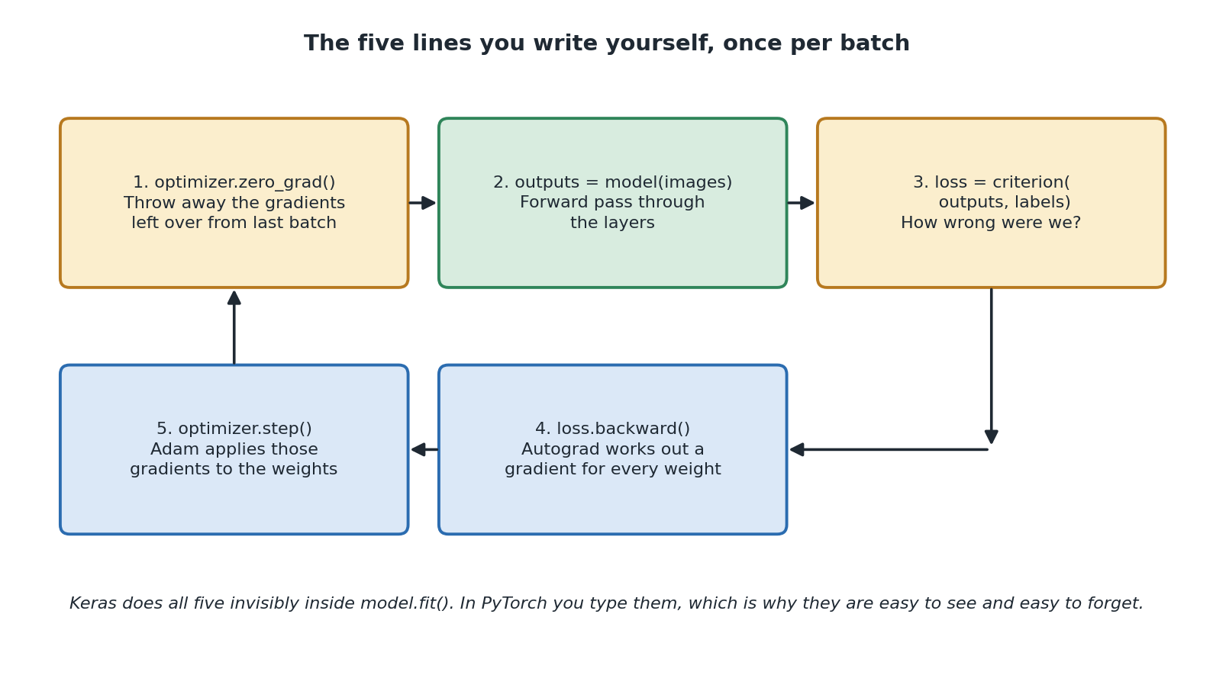
Diagram 6. The five calls that make up one training step, repeated for every batch.
Rebuild specification, Diagram 6: the training loop
Type: cyclic flow diagram. Five rounded rectangles: three across the top row, two on a lower row, with arrows forming a loop that runs left to right along the top then right to left along the bottom and back up.
Top row, left to right: '1. optimizer.zero_grad() / Throw away the gradients left over from last batch' (amber), '2. outputs = model(images) / Forward pass through the layers' (green), '3. loss = criterion(outputs, labels) / How wrong were we?' (amber).
Bottom row, right to left: '4. loss.backward() / Autograd works out a gradient for every weight' (blue), '5. optimizer.step() / Adam applies those gradients to the weights' (blue).
Connectors: arrows box 1 to 2 and 2 to 3 along the top; an elbowed arrow down the right side from box 3 into box 4; an arrow from box 4 left into box 5; a vertical arrow up from box 5 back into box 1, closing the loop.
Italic footer: 'Keras does all five invisibly inside model.fit(). In PyTorch you type them, which is why they are easy to see and easy to forget.'
Palette as Diagram 3.
Line | What it does | What happens if you forget it
optimizer.zero_grad() | Clears the gradients left over from the previous batch. | The most notorious PyTorch bug. Gradients add up instead of replacing, so each step is based on a mixture of this batch and every batch before it. Training goes strange in ways that are hard to diagnose.
outputs = model(images) | The forward pass. Runs the batch through the layers and produces logits. | Nothing to work with.
loss = criterion(outputs, labels) | Compares the predictions with the correct answers and produces one number. | Nothing to minimise.
loss.backward() | The backward pass. Autograd works out a gradient for every one of the 101,770 weights. | The gradients stay empty, so the next line does nothing at all.
optimizer.step() | Adam uses those gradients to actually change the weights. | Nothing ever learns. The loss sits still and you wonder why.
Why does zero_grad exist at all? Because PyTorch accumulates gradients by design. That sounds like an odd default until you meet the situations it enables, such as training on batches too large to fit in memory by processing them in pieces and letting the gradients build up. The cost of that flexibility is that in the ordinary case you must clear them yourself, every time.

10.2 model.train() and what it actually does
model.train() does not train anything. The name is misleading. It sets a flag on the model saying it is in training mode, and layers that behave differently in the two modes read that flag.
In this project one layer cares: Dropout. In training mode it randomly switches neurons off. In evaluation mode it does nothing. Section 11.1 covers the other half of this pair, model.eval(), and why forgetting to switch is a classic bug.

10.3 Counting accuracy by hand
running_loss += loss.item() * images.size(0)
predicted_digits = outputs.argmax(dim=1)
correct += (predicted_digits == labels).sum().item()
total += labels.size(0)
Four lines that Keras would have done for you. Worth reading closely, because they show what a metric actually is.
- argmax(dim=1) finds the position of the biggest score in each row. dim=1 means across the ten digits rather than across the 32 images. That position is the predicted digit.
- Comparing that with the labels gives a tensor of true and false values. Summing it counts how many were right, because true counts as one.
- .item() pulls a plain Python number out of a single-value tensor. You will use it constantly.
- The loss is multiplied by the batch size before adding up, so that the final average is over images rather than over batches. That matters when the last batch is smaller than the rest.
There is nothing mysterious in a metric. It is counting. Seeing it written out once makes every future accuracy figure less abstract.

10.4 Epochs in detail, and the point where more becomes worse
Epochs deserve their own section, because this is the setting people reach for first when they want a better score, and it is the one that will quietly betray you.

What one epoch actually is
An epoch is one complete pass through every training image. Here that is all 60,000, in batches of 32, which is 1,875 trips round the five-line loop. Then epoch two starts and does the whole lot again, five times in total. That is 9,375 weight updates.
A fair question: why show it the same pictures more than once? Surely it either learned from a picture or it did not.
The answer is that each adjustment is deliberately tiny. The optimizer never jumps straight to the right answer, it only nudges. And because all 101,770 numbers are shared across all ten digits, an adjustment made to get one 7 right may partly undo something that was helping with 1s. So the network needs to see everything repeatedly, gradually settling into numbers that work reasonably for all of it at once. Think less like memorising a fact and more like slowly tuning a radio.

What happens across the epochs
Roughly when | What the network is doing | What you see
Epoch 1 | Learning the crude, obvious things. Where ink usually is. Which broad shapes go with which digits. | The biggest single jump of the whole run. Often above 90 percent immediately.
Epochs 2 to 4 | Refining. Harder distinctions like 4 against 9, and unusual handwriting. | Steady but smaller gains, roughly a percent per epoch.
Around epoch 5 here | Most of the general pattern has been learned. | Gains become small and irregular. This is why the project stops at 5.
Beyond that | Running out of general patterns, so it starts fitting the quirks of individual training images. | Training score keeps creeping up. Test score stops improving.
Well beyond that | Actively memorising the training set. | Training score approaches perfect. Test score gets worse.

The critical point
Here is what catches people out. Training accuracy almost never gets worse with more epochs. It climbs and then flattens near perfect. So if that is the number you are watching, more epochs always looks like an improvement.
Test accuracy does something different. It climbs, reaches a peak, and then declines. That peak is the critical point, and it is the number of epochs you actually wanted.
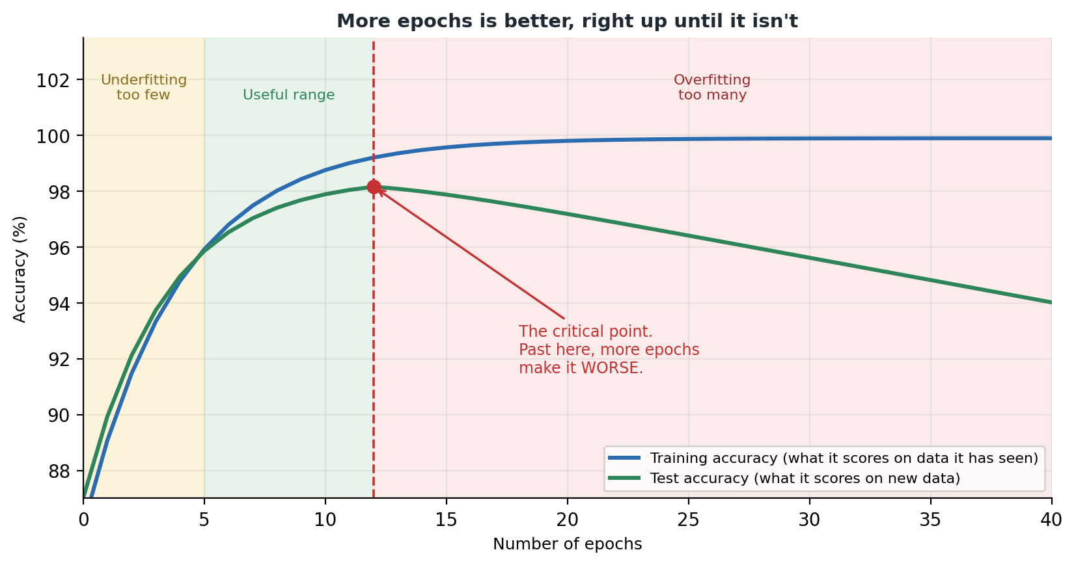
Diagram 7. Training accuracy keeps rising. Test accuracy peaks and then falls.
Rebuild specification, Diagram 7: epochs and the critical point
Type: line chart with three shaded vertical bands behind the curves. X axis 'Number of epochs', 0 to 40 in steps of 5. Y axis 'Accuracy (%)', roughly 87 to 103.
Band 1, x from 0 to 5, pale amber, label at the top in amber: 'Underfitting / too few'.
Band 2, x from 5 to 12, pale green, label at the top in green: 'Useful range'.
Band 3, x from 12 to 40, pale red, label at the top in red: 'Overfitting / too many'.
Curve 1, solid blue, 'Training accuracy (what it scores on data it has seen)': rises steeply from about 87 and flattens just under 100, never falling.
Curve 2, solid green, 'Test accuracy (what it scores on new data)': rises alongside it, peaks at about 98 percent at epoch 12, then declines steadily to about 94 by epoch 40.
A red dashed vertical line at epoch 12 with a red dot on the green curve, and a red annotation with an arrow: 'The critical point. Past here, more epochs make it WORSE.'
Legend bottom right. Light grid, top and right borders removed. Title: 'More epochs is better, right up until it isn't'.
Colours: blue #2B6CB0, green #2F855A, red #C53030, amber band #FBEECD, green band #D8ECDF, red band #FBDCDC.
Note: the curves are illustrative shapes for teaching, not measured output from this project.

Why more training makes it worse
It sounds backwards. More practice should mean better performance. So what is going on?
Remember the exam revision comparison from section 1.4. In the early epochs the model learns genuine patterns, the things that make a 7 a 7 in general. Those help on any 7, including ones it has never seen, which is why both scores rise together at first.
Eventually it has extracted all the general patterns available. The loss can still be reduced, though, because each training image has its own quirks: a smudge, an unusual slant, one person's odd way of closing a 4. Fitting those quirks makes the training loss smaller, so the optimizer happily does it. It has no way to tell a real pattern from a coincidence in the data it was handed.
Those quirks do not appear in new handwriting. Worse, the weights being tuned to fit them are the same weights doing the useful general work, so fitting the noise actively damages the general pattern. That is why the test line does not merely flatten. It turns and goes down.

How to find the critical point
You cannot calculate it. It depends on your data, your network, your dropout and your optimizer. But you can find it.
1. Split a slice off your training data as a validation set. In PyTorch, torch.utils.data.random_split does this, and you wrap each part in its own DataLoader.
2. After each epoch, run the evaluation loop from Step 8 against the validation set as well as printing the training numbers.
3. Train for far more epochs than you think you need. Twenty or thirty.
4. Plot both scores against the epoch number and find where the validation line peaked.
5. Rebuild the model, recreate the optimizer, and retrain for that many epochs.
There is also an automatic version, called early stopping: keep track of the best validation score, save a copy of the weights whenever it improves, and stop when it has not improved for a few epochs. PyTorch has no built-in version, so you write it yourself, which is a genuinely good exercise once the manual method makes sense.
This is a place where PyTorch asks more of you than Keras, which offers validation_split as an argument. Here it is a few extra lines. The upside is that you can see and change exactly what is being held back and when it is measured.

Why this project uses 5
MNIST is a fairly easy problem, the network is small, and dropout is already fighting overfitting on your behalf. Five epochs lands comfortably in the useful range: enough to learn the general patterns, not enough to start memorising. It also finishes in well under a minute, which matters in a teaching notebook where nobody wants to wait five minutes to discover they typed something wrong.

Epochs are not the only dial
What you are seeing | Is more epochs the fix? | What to do instead
Both scores still rising when training stopped | Yes | Train for longer. You stopped early.
Both scores low and flat | No | The network is too small, or the data is not prepared properly.
Training score high, test score much lower | No, definitely not | You have overfitted. Fewer epochs, more dropout, or more data.
Loss barely moved from epoch 1 | No | Something is broken. Check zero_grad, check the loss matches the labels, check the optimizer got model.parameters().
In short
An epoch is one full pass through the training data. The project uses five, which is 9,375 weight updates.
The network needs several passes because each adjustment is small and all the weights are shared.
Training accuracy rises forever. Test accuracy peaks and then falls. That peak is what you want.
Find it with a validation split, not by guessing.
Check you understood
1. Name the five calls in the training loop, in order.
2. What goes wrong if you forget optimizer.zero_grad()?
3. Why does the network need to see the same image more than once?
4. Your training score is 99 percent and your test score is 91 after 40 epochs. What do you do?

11. Testing the model
Key words in this section
Generalisation: doing well on data the model has never seen.
Overfitting: memorising the training data instead of learning the pattern.
Evaluation mode: the model setting that switches off training-only behaviour.
no_grad: a block where PyTorch stops tracking gradients.
model.eval() # switch off Dropout

with torch.no_grad(): # we are not training, so do not track gradients
for images, labels in test_loader:
images, labels = images.to(device), labels.to(device)
outputs = model(images)
loss = criterion(outputs, labels)
predicted_digits = outputs.argmax(dim=1)
correct += (predicted_digits == labels).sum().item()

11.1 The two lines that surround everything
The loop itself is much like the training one, minus the parts that change weights. What is new is the two things wrapped around it, and both are PyTorch-specific traps worth understanding properly.

model.eval()
This switches the model into evaluation mode. Dropout stops dropping. If you forget it, dropout stays active during testing, so your scores come out worse than they should and, because dropout is random, they change slightly every time you run the cell.
That last symptom is the giveaway. Evaluation should be perfectly repeatable. If your test accuracy wobbles between runs, you almost certainly forgot model.eval().
The pair is model.train() and model.eval(), and you switch back and forth. Notice that the notebook's canvas code in Step 11 and the backpropagation bonus both call these too, for exactly this reason.

torch.no_grad()
Normally PyTorch records every calculation involving tensors, so that it can work backwards later. That recording is what makes training possible, and it costs both time and memory.
During evaluation you are never going to work backwards. So wrapping the loop in with torch.no_grad() tells PyTorch to stop recording. Evaluation runs faster and uses noticeably less memory. Forgetting it is not wrong in the sense of producing bad numbers, it is just wasteful, and on a large model it can be the difference between fitting in memory and not.
These two do different jobs and people mix them up. model.eval() changes how layers behave. torch.no_grad() changes whether calculations are recorded. You want both, and one does not imply the other.

11.2 What 97 to 98 percent means
The project expects around 97 to 98 percent, meaning 200 to 300 mistakes across the 10,000 test images. Whether that is good depends entirely on what you are doing with it.
Used for | Good enough? | Why
A classroom demonstration | Yes, easily | Mistakes cost nothing and are interesting to look at.
Sorting post by postcode | Possibly, with a backup | Anything uncertain goes to a person. A mistake costs a redelivery.
Reading a six digit account number | No | See below.
Reading the amount on a cheque | No | Money mistakes are unacceptable, and the same maths applies.
If each digit is right 98 percent of the time, all six being right at once is 0.98 multiplied by itself six times, which is about 0.89. So roughly one record in nine would have an error somewhere in it.
This is the most useful thing to take from that percentage. Being right per item and being right per job are very different numbers, and confusing them is how projects get approved on a figure that cannot support them.

11.3 Overfitting and underfitting
Your test accuracy should be very close to your final training accuracy, and may be slightly lower. That closeness is a good sign: it means the model learned general patterns rather than memorising pictures.
Training score | Test score | Diagnosis | What to do
High, e.g. 98% | High and close, e.g. 97.5% | Healthy. This is what this project produces. | Nothing.
Very high, e.g. 99% | Much lower, e.g. 80% | Overfitting. It memorised the training set. | More dropout, more data, a smaller network, or fewer epochs.
Low, e.g. 85% | Low, e.g. 84% | Underfitting. It never learned the pattern. | Train longer, use a bigger network, or check the data.
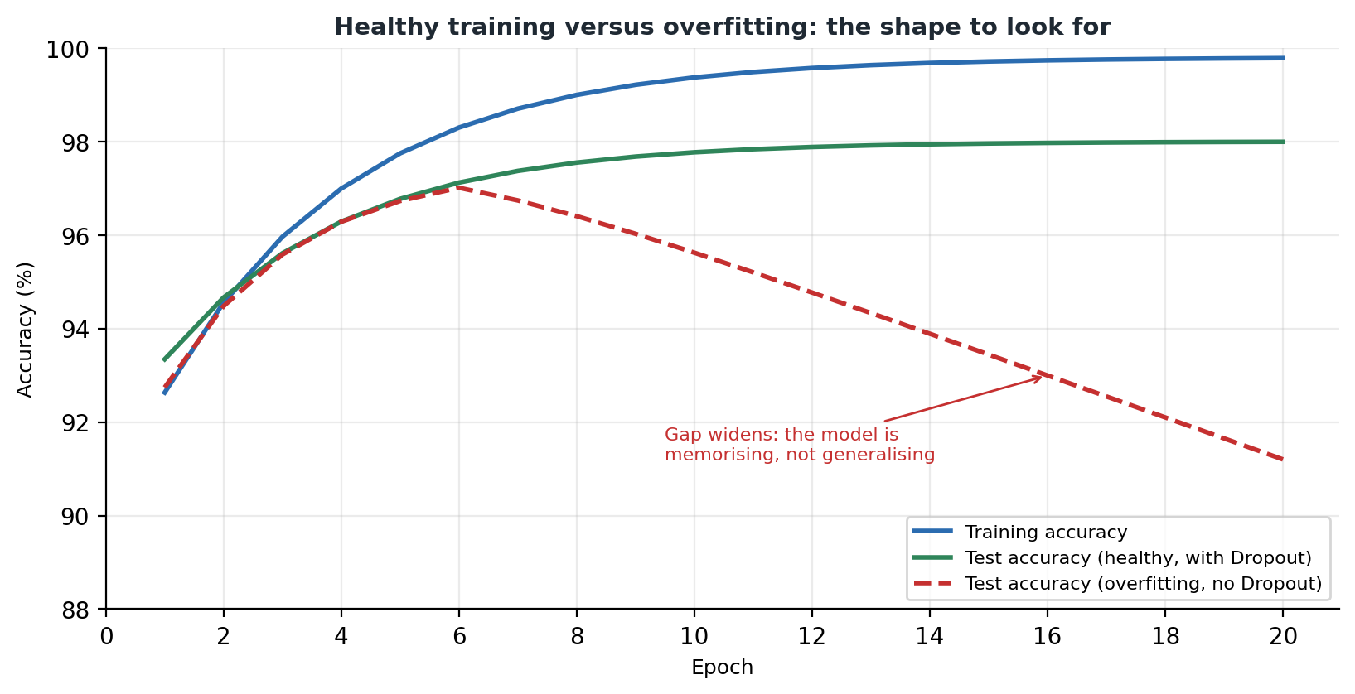
Diagram 8. What overfitting looks like on a graph: the two lines pull apart.
Rebuild specification, Diagram 8: healthy training versus overfitting
Type: line chart. X axis 'Epoch', 0 to 20 in steps of 2. Y axis 'Accuracy (%)', 88 to 100.
Three curves, each rising steeply then flattening: solid blue 'Training accuracy' from about 90 to 99.5, still creeping up; solid green 'Test accuracy (healthy, with Dropout)' from about 91.5 to 98 then flat, staying just below the blue; dashed red 'Test accuracy (overfitting, no Dropout)' peaking near 97 around epoch 6 then declining to about 94 by epoch 20.
Red annotation with an arrow pointing at the red curve near epoch 16: 'Gap widens: the model is memorising, not generalising'.
Legend bottom right. Light grid, top and right borders removed. Title: 'Healthy training versus overfitting: the shape to look for'.
Colours: blue #2B6CB0, green #2F855A, red #C53030.
Note: illustrative shapes for teaching, not measured output from this project.
Look for the shape, not the exact numbers. When the training line keeps climbing while the test line flattens or turns down, the model has stopped learning the problem and started learning the answers.

11.4 If your accuracy looks low
Check | Why
Did you call model.eval() before testing? | Dropout still active means worse and unrepeatable scores.
Did you run every cell from the top, in order? | A notebook remembers what you ran. Out of order, anything can happen.
Did you rebuild the model without rebuilding the optimizer? | The optimizer would still be pointing at the old parameters.
Is optimizer.zero_grad() present in the loop? | Without it the gradients accumulate and training behaves strangely.
Did Step 7 finish before you ran Step 8? | The notebook prints a reminder for exactly this reason.

11.5 What one accuracy number hides
- Which digits it gets wrong. Mistakes are not spread evenly. 4 and 9, or 3 and 5, cause more than their share.
- How confident it was when wrong. Wrong at 35 percent confidence is reasonable behaviour. Wrong at 99 percent is not, and accuracy alone cannot tell you which is happening.
- How it handles input unlike the training data. Section 13 shows you this directly with the canvas.
- Whether the categories are balanced. MNIST is fairly even, so accuracy is a fair summary here. On uneven data a model can score highly while never predicting the rare category at all.
In short
Test on data the model has never seen. That is the only honest score.
Always call model.eval() and wrap the loop in torch.no_grad(). They do different jobs and you want both.
Training and test scores close together is healthy. A big gap means overfitting.
Check you understood
1. What does model.eval() change, and what is the symptom of forgetting it?
2. What does torch.no_grad() change, and why use it?
3. If each digit is right 98 percent of the time, roughly how often is a four digit number entirely correct?

12. Making predictions
Key words in this section
Logits: the raw scores the model produces.
Softmax: turns those scores into probabilities adding up to 1.
argmax: finds the position of the biggest number.
full_test_loader = DataLoader(test_dataset, batch_size=len(test_dataset), shuffle=False)
x_test_tensor, y_test_tensor = next(iter(full_test_loader))

model.eval()
with torch.no_grad():
logits = model(x_test_tensor.to(device))
predictions = torch.softmax(logits, dim=1).cpu().numpy()
There is a small trick in the first two lines. Rather than loop over batches, the notebook creates a DataLoader whose batch size is the entire test set, then pulls one batch from it. That gives all 10,000 images in a single tensor, which is convenient for indexing and plotting.

12.1 From logits to something readable
This is where the missing softmax from section 8.8 finally appears. The model returns raw scores, and torch.softmax turns them into probabilities.
dim=1 says which direction to apply it. The tensor is shaped (10000, 10), so dimension 0 is the images and dimension 1 is the ten digits. You want each image's ten scores to add up to 1, not each digit's ten thousand scores, so dim=1 is correct. Getting this wrong is a classic error that produces numbers which look plausible and mean nothing.
Then .cpu() moves the result back from the graphics card if it was on one, and .numpy() converts it into a plain array for matplotlib. If you are on the processor the .cpu() call does nothing, and it is included so the code works either way.

12.2 Reading the ten numbers
[0.01, 0.00, 0.02, 0.01, 0.00, 0.00, 0.00, 0.94, 0.00, 0.02]
Reading left to right, position 0 holds 0.01, position 1 holds 0.00, and so on. The biggest is 0.94 at position 7, so the model thinks this is a 7 and is 94 percent confident. The leftover confidence is scattered across a few other digits.
np.argmax finds the position of the biggest value. That the position happens to equal the digit is lucky here, because the categories are the numbers 0 to 9 in order. In another problem, position 3 might mean cat and you would need a lookup list.
Get into the habit of looking at all ten numbers rather than just the winner. A right answer at 0.94 and a right answer at 0.34 with a close second are very different situations, even though both count as correct. In a real system that difference is exactly how you decide which cases to send to a human.

12.3 The three ways the project shows results
What it shows | Step | Why it is there
The ten numbers printed out | 9 | Makes it obvious the model outputs a spread of confidence, not a single answer.
A bar chart of the ten numbers next to the picture | 9b | Easier to read. A tall lone bar means certainty. Several similar bars mean genuine uncertainty.
A grid of pictures labelled green or red | 10 | A quick scan for mistakes and a feel for which digits go wrong.
The three views go from exact but hard to read, through easy to interpret, to quick but shallow. Picking the right level of detail for the question you are asking is a skill that applies well beyond this project.

13. The drawing canvas
Key words in this section
Preprocessing: getting input into the same form as the training data.
Online learning: updating a trained model from new examples one at a time.
Catastrophic forgetting: a model losing what it knew after being retrained on a few examples.
Step 11 is what makes this more than a tutorial. It gives you a 200 by 200 canvas to draw on with the mouse and tests the model on your handwriting instead of on more MNIST pictures.
This is where the project stops being an exercise and becomes an experiment. That 98 percent was measured on pictures from the same source as the training pictures. Your drawing comes from a completely different source: you, with a mouse, on a screen. The difference between those two scores is one of the most useful things in the whole project.

13.1 How the canvas is built
- ipycanvas provides the Canvas widget, created with sync_image_data=True. That flag is what lets Python read back what you drew. Without it the drawing exists only in the browser.
- The canvas is filled black with a white pen, line width 14 and rounded ends, matching how MNIST digits look.
- It is 200 by 200, chosen so the whole drawing area fits on screen without scrolling.
- Three handlers track the mouse: pressing down, moving, and letting go. A true or false variable remembers whether you are currently drawing.
- ipywidgets provides the Predict, Clear, Yes correct and No wrong buttons, the digit dropdown, and two output areas.

13.2 Turning a drawing into a tensor
You cannot hand a drawing straight to the model. It has to be changed until it matches the training pictures. This function is probably the most instructive code in the project.
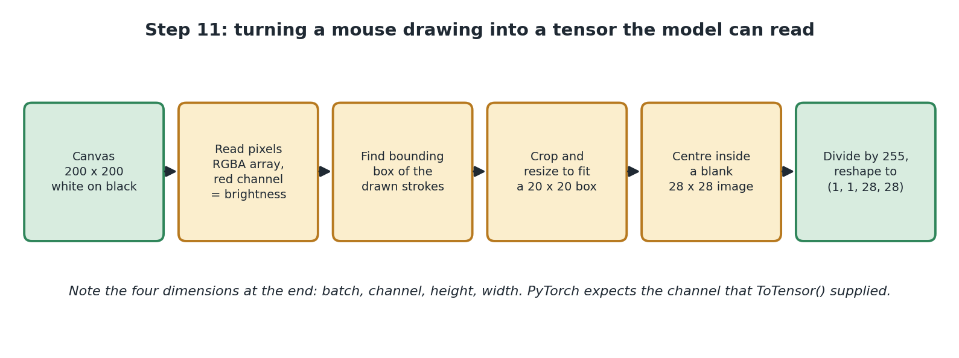
Diagram 9. The six stages that turn your drawing into model input.
Rebuild specification, Diagram 9: canvas preprocessing pipeline
Type: linear pipeline diagram. Six equally sized rounded rectangles in one horizontal row, joined left to right by solid single headed arrows.
Box 1 (green): 'Canvas / 200 x 200 / white on black'.
Box 2 (amber): 'Read pixels / RGBA array, red channel = brightness'.
Box 3 (amber): 'Find bounding box of the drawn strokes'.
Box 4 (amber): 'Crop and resize to fit a 20 x 20 box'.
Box 5 (amber): 'Centre inside a blank 28 x 28 image'.
Box 6 (green): 'Divide by 255, reshape to (1, 1, 28, 28)'.
Title above: 'Step 11: turning a mouse drawing into a tensor the model can read'. Italic footer: 'Note the four dimensions at the end: batch, channel, height, width. PyTorch expects the channel that ToTensor() supplied.'
Palette as Diagram 3. Green marks the endpoints, amber marks the transformation stages.
Stage | The code | Why it is needed
Read the canvas | canvas.get_image_data() | Gives back four numbers per pixel: red, green, blue and transparency.
Keep only brightness | image_data[:, :, 0] | The drawing is white on black, so red, green and blue are identical. Taking the first gives brightness from 0 to 255 and throws away two copies.
Find where the ink is | np.any(brightness > 0, ...) | Works out which rows and columns contain any ink, giving a box around your drawing.
Handle an empty canvas | if not drawn_rows.any(): return None | Stops it crashing if you press Predict without drawing. It prints 'Draw a digit first!' instead.
Crop and shrink | digit.thumbnail((20, 20)) | Cuts away empty space, then shrinks to fit a 20 by 20 box without squashing.
Centre it | canvas_28.paste(digit, ...) | Puts the drawing in the middle of a blank 28 by 28 black square, leaving a border like MNIST has.
Scale the numbers | np.array(canvas_28) / 255.0 | Reproduces by hand exactly what ToTensor() did to the training images.
Make it a tensor | torch.tensor(...).reshape(1, 1, 28, 28) | Batch of one, one channel, 28 by 28. The four dimensions the model expects.
That last row is the PyTorch-specific part. The TensorFlow version reshapes to (1, 28, 28) with three dimensions. Here you need four, because ToTensor gave the training images a channel dimension and the model has been built expecting it ever since.

13.3 The most useful lesson in the project
Cropping to 20 by 20 and centring in a 28 by 28 square is not tidying up. It is essential.
MNIST digits are all a similar size and sit in the middle with a border. So the model's 100,480 input weights are tuned to expect ink in the middle of the picture, at roughly that size. It has never seen anything else.
Skip the centring and predictions get noticeably worse, even when your drawing is perfectly clear to a human eye. The model is not confused the way a person would be. It is being asked about a region of its input it has no experience of, and its answers there are close to random.
In short
Whatever was done to the training data must be done to anything you show the model later.
This is called training and serving skew, and it causes more disappointing real world results than bad models do.
In PyTorch it bites twice: the scaling that ToTensor did automatically, and the channel dimension it added.

13.4 Teaching the model when it is wrong
After each prediction you are asked if it was right. Click No, wrong and you get a dropdown and a Teach the model button. That button runs the same five-line loop from Step 7, a handful of times, on your single drawing.
model.train()
for _ in range(3):
optimizer.zero_grad()
outputs = model(image_tensor)
loss = criterion(outputs, correct_label)
loss.backward()
optimizer.step()
model.eval()
Notice the model.train() and model.eval() bracketing it. Dropout needs to be active while learning and off again afterwards, so the canvas switches modes around the update. That small detail is easy to miss and would quietly change behaviour if it were left out.
This is online learning: updating a model that has already been trained, rather than starting again.

Why it works
Nothing about training requires a big dataset. The loop does exactly the same thing on one image that it does on 60,000. The weights move in the direction that reduces the error on that one image.

Why you should not trust it
For exactly the same reason. The adjustment aims at getting your one drawing right, with nothing pulling in the other direction on behalf of the other 60,000. Do it enough times and the model drifts towards your handwriting and gets worse at everything else. This is catastrophic forgetting, a genuine unsolved problem rather than a flaw in this code.
There is a bigger point underneath. A system that updates itself whenever a user says it is wrong can very easily become a system that agrees with the user rather than a system that is correct.
The README explains how to undo it: re-run Step 5 to rebuild the model, Step 6 to recreate the optimizer, and Step 7 to retrain. All three, in that order. This is the same optimizer-points-at-parameters issue from section 9.1, and forgetting Step 6 leaves you training a fresh model with an optimizer aimed at a model that no longer exists.
Check you understood
1. Why is the canvas black with a white pen rather than the other way round?
2. Why does the drawing need four dimensions rather than three?
3. Why does the teach function call model.train() and then model.eval()?

14. Saving the trained model
Key words in this section
state_dict: a dictionary of a model's learned weights, without its structure.
torch.save(model.state_dict(), "handwritten_digit_model_pytorch.pt")

# To load it again later:
# model = HandwrittenDigitClassifier()
# model.load_state_dict(torch.load("handwritten_digit_model_pytorch.pt"))
# model.eval()
Training takes time. Saving means you never have to repeat it. But what gets saved here is different from what you might expect, and the notebook makes a point of it.

14.1 What a state_dict is
A state_dict is a plain Python dictionary mapping each layer's name to its current tensor of numbers. Something like hidden.weight pointing at a 128 by 784 tensor, hidden.bias pointing at 128 numbers, and so on.
That is all it holds. The learned numbers. It does not contain the architecture, the layer definitions, the loss function or the optimizer.

14.2 Why loading takes two steps
Because the file has no idea what shape of model those numbers belong to, you have to tell it. So loading is:
1. Create an empty, untrained model using the same class definition from Step 5.
2. Pour the saved numbers into it with load_state_dict.
3. Call model.eval(), because a freshly created model is in training mode by default and you almost certainly want to predict with it.
The consequence is important: the file alone is not enough. You must keep the class definition too. Lose the code and your saved weights are a large collection of numbers nobody can use.

14.3 Why PyTorch does it this way
 | PyTorch state_dict | Keras .keras file
Contains | Learned weights only | Architecture, weights, optimizer state and compile settings
Loading | Two steps: rebuild the class, then load the numbers | One line, gives you a working model
You must also keep | The model class definition | Nothing
File size | Smaller | Larger
Ties to code versions | Loosely, since it is only numbers | More tightly, since it stores a whole object
Saving only the numbers keeps the file small and avoids tying it to exact library versions the way storing a whole Python object can. The trade is that you are responsible for keeping the class around.
Neither approach is better. They express different priorities: Keras optimises for convenience, PyTorch for keeping the saved artefact simple and stable. Knowing which you are working with matters the day you try to load a file from a year ago.
PyTorch does let you save the whole model object with torch.save(model, path), and the documentation advises against it for exactly the version-fragility reason above. If you see that form in a tutorial, know that it works and is not recommended.

15. Bonus: watching backpropagation happen
Key words in this section
Gradient: a number saying which way to nudge a weight, and how much that weight matters.
Chain rule: the piece of calculus that works out an effect through a chain of steps.
Autograd: PyTorch's engine for doing that automatically.
.grad: the attribute on a tensor where its gradient gets stored.
Section 10.1 said that loss.backward() works out a gradient for every weight, and moved on. This bonus section opens that up. It is worth working through, because backpropagation has a reputation for impenetrable maths and turns out to be something you can check by hand in about four lines.
There is a nice difference from the TensorFlow version here. That notebook has to introduce a whole new tool to show you gradients, because Keras never exposes them. In PyTorch you have been calling loss.backward() since Step 7. The gradients were always there. This section just looks at them.

15.1 What a gradient actually is
A gradient is a slope. If you have a weight and want to know what happens to the loss when you nudge it slightly, the gradient is the answer. It tells you two things at once:
- The sign, positive or negative, tells you which direction to move. If increasing the weight increases the loss, go the other way.
- The size tells you how much this weight matters right now. Near zero means nudging it would barely change anything. Large means it has real influence.
There is one gradient per weight. This project has 101,770 weights, so every training step produces 101,770 gradients. The optimizer takes that list and decides how far to move each one. That is the whole of training in a sentence.

15.2 How autograd works
When a tensor is marked with requires_grad=True, PyTorch starts watching it. Every calculation involving it gets recorded onto a graph as it happens. Call backward() on the final result and PyTorch walks that graph backwards, applying the chain rule at each step, writing the answer into each tensor's .grad attribute.
Model parameters have requires_grad=True set automatically when nn.Linear creates them, which is why you never had to think about this during Steps 5 to 12.
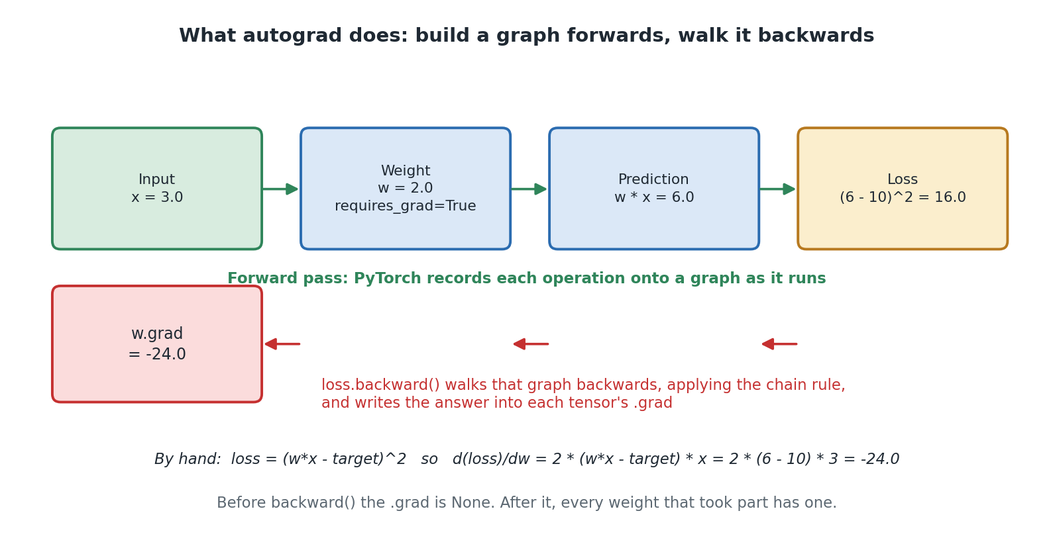
Diagram 10. Autograd builds a graph as the calculation runs forwards, then walks it backwards.
Rebuild specification, Diagram 10: what autograd does
Type: two-row process diagram, forward across the top, backward beneath.
Top row: four rounded rectangles left to right joined by green arrows: 'Input / x = 3.0' (green), 'Weight / w = 2.0 / requires_grad=True' (blue), 'Prediction / w * x = 6.0' (blue), 'Loss / (6 - 10)^2 = 16.0' (amber).
Directly beneath, centred, in bold green: 'Forward pass: PyTorch records each operation onto a graph as it runs'.
Second row: three short red arrows pointing LEFT, under the gaps between the boxes above, feeding into a red rounded rectangle at the far left: 'w.grad / = -24.0'.
Red text to the right of that box: 'loss.backward() walks that graph backwards, applying the chain rule, and writes the answer into each tensor's .grad'.
Italic caption at the bottom: 'By hand: loss = (w*x - target)^2 so d(loss)/dw = 2 * (w*x - target) * x = 2 * (6 - 10) * 3 = -24.0'.
Grey caption below: 'Before backward() the .grad is None. After it, every weight that took part has one.'
Colours: green #2F855A on #D8ECDF, blue #2B6CB0 on #DBE8F7, amber #B7791F on #FBEECD, red #C53030 on #FBDCDC.

15.3 The toy example, and checking it by hand
The notebook starts as small as possible: one input, one weight, one multiplication. Small enough that you can do the maths yourself and compare.
x = torch.tensor(3.0) # a fixed input
target = torch.tensor(10.0) # what we wish the prediction was
w = torch.tensor(2.0, requires_grad=True) # our one and only weight

prediction = w * x # forward pass
loss = (prediction - target) ** 2 # how wrong were we?

loss.backward() # backward pass
print(w.grad.item())
Follow the numbers. The prediction is 2 times 3, which is 6. We wanted 10, so we are 4 out. Squaring that gives a loss of 16.
Now the question backpropagation answers: if we nudged w up slightly, would the loss rise or fall, and by how much?
# loss = (w*x - target)^2
# d(loss)/dw = 2 * (w*x - target) * x
# = 2 * (6 - 10) * 3
# = -24.0
Both come out at exactly -24.0. Not close, exactly. PyTorch did not guess or approximate. It mechanically applied the same chain rule you would use with a pen.
The sign tells you the loss falls as w increases, which makes sense: our prediction of 6 is too low and raising w would raise it. The size, 24, says this weight matters a lot right now. Both are exactly what the optimizer needs.
If the calculus is unfamiliar, do not let it stop you. The point is not that you can differentiate a squared bracket. It is that the mysterious step inside training turns out to be small, checkable arithmetic, done many times over.

15.4 The same thing on the real model
images, labels = next(iter(train_loader))
optimizer.zero_grad()

print(model.hidden.weight.grad) # None, nothing calculated yet

outputs = model(images)
loss = criterion(outputs, labels)
loss.backward()

first_layer_gradients = model.hidden.weight.grad # now a real tensor
The best detail in this cell is the print before backward(). The .grad attribute is None, meaning nothing has been calculated. After backward() it is a full tensor, the same shape as the weight matrix it belongs to. You can watch it come into existence.
One gradient per weight, no exceptions, nothing grouped or approximated. That is what makes the whole thing work.
Remember from section 8.3 that PyTorch stores a Linear layer's weights as (outputs, inputs), so this tensor is (128, 784): neurons first, pixels second. That is why the notebook indexes it as [:5, 400] rather than [400, :5]. The TensorFlow version is the other way round, and the notebook flags the difference explicitly.

15.5 The zero gradients, and why they are not a bug
This is the best bit, and it ties back to things covered much earlier.
The notebook prints gradients for pixel 400, roughly in the middle of the image, and gets a spread of real numbers. It then invites you to change 400 to 0 and re-run. You get back exactly zero. Not very small. Exactly zero.
The reason is lovely. Pixel 0 is a corner, and section 6.5 established that MNIST digits are centred with black borders, so that pixel is 0 in essentially every training image. A weight that only ever gets multiplied by zero cannot affect the loss whatever value it takes. Its gradient is therefore exactly zero, and the optimizer correctly leaves it alone.
The network has worked out for itself that there is nothing to learn about the corners of the picture. Nobody told it. It falls out of the arithmetic.
It is also a neat illustration of section 8.3. Weights near zero mean the neuron does not care about that input, and here you can see the mechanism that makes it so.

15.6 Applying one real update
import copy
original_state = copy.deepcopy(model.state_dict()) # so we can undo this

weight_before = model.hidden.weight[0, 400].item()
optimizer.step() # one real update
weight_after = model.hidden.weight[0, 400].item()

model.load_state_dict(original_state) # put it back
optimizer.zero_grad()
The change printed is small, which is exactly right. Section 10.4 explained that the network needs many passes precisely because each adjustment is deliberately tiny. Here is one of those adjustments, measured.
Note the save and restore either side, and that it uses copy.deepcopy. Without deepcopy you would be holding a reference to the live tensors rather than a snapshot, so they would change underneath you and restoring would do nothing. That is a subtle Python point worth understanding.
The final zero_grad matters too. It clears the gradients this demonstration produced, so the next thing you run does not inherit them. A demonstration that changes shared state is a bug waiting to appear three cells later, and this one is careful not to be.

15.7 Why this section is worth your time
- It removes the magic. Training stops being something that mysteriously happens and becomes a mechanism you have watched work, on numbers you checked yourself.
- It makes the failure modes make sense. Once you have seen that training is repeated small steps down a slope, it becomes obvious why the learning rate matters, why a gradient of zero means nothing is learned, and why forgetting zero_grad ruins everything.
In short
A gradient is a slope: which way to nudge a weight, and how much that weight matters.
Autograd records the forward calculation onto a graph and backward() walks it backwards. That walk is backpropagation.
The notebook checks PyTorch's gradient against hand-worked calculus and gets an exact match.
Corner pixels give gradients of exactly zero, because they are always zero in the training data.
Check you understood
1. What two pieces of information does a single gradient give you?
2. What is .grad before backward() is called, and after?
3. Why does the gradient for a corner pixel come out as exactly zero rather than very small?

16. A better design: convolutional networks
Key words in this section
Convolution: sliding a small filter across an image to look for a pattern.
Filter: a small grid of learned numbers that detects one feature, such as an edge.
Pooling: shrinking a grid by keeping only the strongest values.
Channel: one of the stacked grids flowing through a convolutional network.
The notebook ends with a runnable convolutional model plus a list of exactly which cells you would change to convert the whole notebook. The bonus cell stands alone, so you can run and compare without breaking the working version above it.

16.1 The problem being fixed
Section 8.5 established that flattening throws away which pixels were next to each other. Two problems follow.
- It cannot reuse what it learns. Learn to spot a horizontal stroke in the top left and that knowledge does nothing for the same stroke in the top right. Each position has to be learned separately.
- It does not scale. 784 pixels into 128 neurons needs 100,480 numbers. An ordinary 256 by 256 colour photo has 196,608 pixels, which would need over 25 million numbers for the same first layer.

16.2 What a convolution does
Picture a small window, 3 pixels by 3, sliding across the image one step at a time. At each position it looks at the 9 pixels underneath, multiplies them by 9 learned numbers, adds them up, and writes the answer into a new grid.
Crucially it uses the same 9 numbers at every position. That is the whole idea, and it fixes both problems at once. A pattern learned in one place gets found everywhere, and the count of learned numbers no longer grows with the size of the picture.
One filter learns one small feature: an edge at a particular angle, a corner, a short curve. nn.Conv2d(in_channels=1, out_channels=32, kernel_size=3) means 32 filters are learned at once, producing 32 new grids each showing where its feature was found. The second convolutional layer, with 64 filters, then looks for combinations of those. That is how the network builds up from edges to loops to whole digits.
in_channels and out_channels are worth reading carefully. in_channels is how many grids arrive, which is 1 for a greyscale image and 32 after the first conv layer. out_channels is how many filters this layer learns. Getting these the wrong way round is a common first mistake.

16.3 What pooling does
nn.MaxPool2d(kernel_size=2) chops the grid into 2 by 2 squares and keeps only the biggest number in each. This halves the width and height, cutting the work for later layers. It also adds a little tolerance for position: a feature that moves by one pixel usually still lands in the same square.

16.4 The bonus model
class CNNClassifier(nn.Module):
def __init__(self):
super().__init__()
self.conv1 = nn.Conv2d(in_channels=1, out_channels=32, kernel_size=3)
self.pool = nn.MaxPool2d(kernel_size=2)
self.conv2 = nn.Conv2d(in_channels=32, out_channels=64, kernel_size=3)
self.flatten = nn.Flatten()
self.fc1 = nn.Linear(64 * 5 * 5, 64)
self.relu = nn.ReLU()
self.dropout = nn.Dropout(0.3)
self.fc2 = nn.Linear(64, 10)

def forward(self, x):
x = self.pool(self.relu(self.conv1(x)))
x = self.pool(self.relu(self.conv2(x)))
x = self.flatten(x)
x = self.relu(self.fc1(x))
x = self.dropout(x)
x = self.fc2(x)
return x
Notice that self.pool and self.relu are each created once and used twice. Because they hold no learned numbers, reusing them is fine and it keeps the class shorter. You could not do that with the conv layers, which each have their own weights.
Notice too that forward reads as nested function calls: pool(relu(conv1(x))). That is just ordinary Python, and it is the kind of thing the class-based approach makes natural.
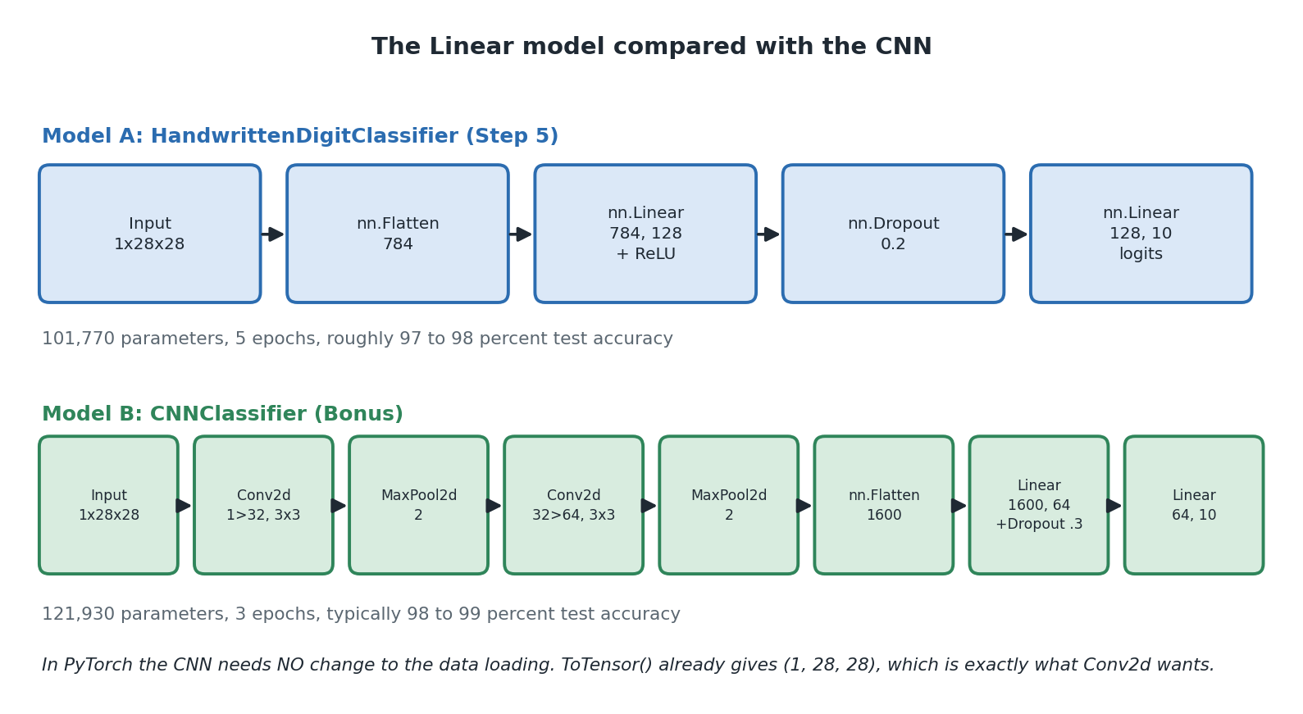
Diagram 11. The two models side by side.
Rebuild specification, Diagram 11: Linear model versus CNN
Type: comparison diagram, two labelled horizontal pipelines stacked vertically, aligned on a common left margin so the difference in depth is visible.
Upper pipeline, heading in bold blue: 'Model A: HandwrittenDigitClassifier (Step 5)'. Five blue rounded rectangles joined by arrows: 'Input 1x28x28', 'nn.Flatten 784', 'nn.Linear 784, 128 + ReLU', 'nn.Dropout 0.2', 'nn.Linear 128, 10 logits'. Grey caption beneath: '101,770 parameters, 5 epochs, roughly 97 to 98 percent test accuracy'.
Lower pipeline, heading in bold green: 'Model B: CNNClassifier (Bonus)'. Eight narrower green rounded rectangles joined by arrows: 'Input 1x28x28', 'Conv2d 1>32, 3x3', 'MaxPool2d 2', 'Conv2d 32>64, 3x3', 'MaxPool2d 2', 'nn.Flatten 1600', 'Linear 1600, 64 +Dropout .3', 'Linear 64, 10'. Grey caption beneath: '121,930 parameters, 3 epochs, typically 98 to 99 percent test accuracy'.
Italic footer at the bottom: 'In PyTorch the CNN needs NO change to the data loading. ToTensor() already gives (1, 28, 28), which is exactly what Conv2d wants.'
Title above both: 'The Linear model compared with the CNN'.

16.5 Working out 1600 by hand
This is the part PyTorch makes you do and Keras does not. nn.Linear needs to be told its input size, so you have to work out how big the data is by the time it reaches that layer. The notebook explains the arithmetic, and it is worth following.
Layer | Grid size after it | Numbers learned | Working
Input | 1 x 28 x 28 | 0 | One greyscale channel.
Conv2d 1 to 32, 3x3 | 32 x 26 x 26 | 320 | A 3 by 3 window with no padding loses one pixel each side, so 28 becomes 26. 32 filters x 9 numbers x 1 channel, plus 32 biases.
MaxPool2d 2 | 32 x 13 x 13 | 0 | Halves both sides.
Conv2d 32 to 64, 3x3 | 64 x 11 x 11 | 18,496 | 13 becomes 11. 64 filters x 9 numbers x 32 incoming channels, plus 64 biases.
MaxPool2d 2 | 64 x 5 x 5 | 0 | 11 halved and rounded down to 5.
nn.Flatten | 1600 | 0 | 64 x 5 x 5 = 1600.
nn.Linear(1600, 64) | 64 | 102,464 | 1600 x 64, plus 64 biases.
nn.Dropout(0.3) | 64 | 0 | A behaviour only.
nn.Linear(64, 10) | 10 | 650 | 64 x 10, plus 10 biases.
Total |  | 121,930
If you get that number wrong you get a shape mismatch error the moment you train. Annoying, but at least it fails loudly rather than quietly doing something wrong. Working it through by hand once is the best way to make convolutions feel concrete rather than magical.

16.6 What changes, and what does not
This is where PyTorch comes off noticeably better than the TensorFlow version, and the notebook says so.
Step | Change needed in PyTorch | Change needed in TensorFlow
Step 2, load the data | None at all. ToTensor already gives (1, 28, 28), exactly what Conv2d wants. | Reshape to add a channel dimension
Step 5, build the model | Replace the class with CNNClassifier | Replace the layer list
Step 6, loss and optimizer | None | None
Step 7, train | None | Use the reshaped data
Step 8, evaluate | None | Use the reshaped data
Step 9, predict | None | Use the reshaped data
Step 11b, canvas | None. It already reshapes to (1, 1, 28, 28). | Add the channel dimension
Step 12, save | None | None
Only Step 5 changes. Every other step works untouched, because they only ever call model(images) and never care what is inside. That is a genuine benefit of the class-based approach: the model is a black box with a consistent interface, so swapping it out changes nothing around it.
It also happens because PyTorch's images already carry a channel dimension from the very beginning. The Linear model only worked with that shape because nn.Flatten collapsed it first. In other words, PyTorch's slightly fussier default shape pays off here.

16.7 Comparing the two models
 | Linear model | CNN
Dropout | 0.2 | 0.3
Epochs | 5 | 3, because each epoch does more work
Loss and optimizer | CrossEntropyLoss, Adam | Identical. Only the architecture changed.
Numbers learned | 101,770 | 121,930, about 20 percent more
Typical test accuracy | 97 to 98 percent | 98 to 99 percent
Training time | Well under a minute | Noticeably longer, since each image takes more work
The CNN does better in fewer epochs with only 20 percent more numbers. The improvement comes from a better design, not from being bigger, which is a good antidote to the assumption that bigger always wins.
Notice also that going from 98 to 99 percent halves the number of mistakes. Each further step costs much more effort than the last. That is normal in this field.

17. PyTorch and Keras side by side
The notebook's summary includes a comparison table, and this section expands it. If you are studying both projects, this is the section to read twice. If you are only studying this one, it still tells you something useful: which parts of what you learned are about neural networks and which are just about PyTorch.

17.1 The concept-by-concept mapping
Concept | Keras | PyTorch
Defining a model | Sequential([...]), a list of layers | A class with __init__ for the parts and forward for the flow
Normalising pixels | Manual: x_train = x_train / 255.0 | Automatic, inside transforms.ToTensor()
Image shape | (28, 28), channel added only when needed | (1, 28, 28), channel present from the start
Batching | Automatic inside model.fit() | Explicit DataLoader objects you create
Final layer | Dense(10, activation="softmax"), outputs probabilities | Linear(128, 10), outputs raw logits
Where softmax happens | Inside the model | Inside the loss during training, applied by hand for display
Configuring training | One model.compile() call | Two objects: criterion and optimizer
Loss for this problem | sparse_categorical_crossentropy | nn.CrossEntropyLoss
Training | model.fit(x, y, epochs=5) | A loop you write: zero_grad, forward, loss, backward, step
Tracking accuracy | Automatic via metrics=["accuracy"] | Counted by hand inside the loop
Training versus evaluation mode | Handled automatically | Explicit model.train() and model.eval()
Evaluating | model.evaluate(x, y) | A loop, wrapped in model.eval() and torch.no_grad()
Model summary | model.summary() prints a table | print(model) plus counting parameters yourself
Seeing gradients | Needs a special tool, tf.GradientTape | Already there. loss.backward() populates .grad
Saving | One self-describing .keras file | A state_dict of weights only, plus the class definition
GPU on Windows | Not supported after TensorFlow 2.10 | Supported normally
Weight matrix layout | (inputs, outputs) | (outputs, inputs)
Converting to a CNN | Data loading and model both change | Only the model changes

17.2 What this tells you about frameworks
Read down that table and a pattern emerges. Keras optimises for getting something working quickly with sensible defaults. PyTorch optimises for visibility and control. Neither is better outright, and the notebook is careful to say so.
The practical consequences run both ways.
 | Keras | PyTorch
Lines of code for this project | Fewer | More
Things you can get wrong | Fewer | More: zero_grad, eval mode, double softmax, shape maths
Things you can see happening | Fewer | More
Ease of doing something unusual | Harder, you fight the abstraction | Easier, you just write different code
Good for | Getting a standard model working fast | Research, custom training, and learning how it works
For learning purposes, the extra typing in PyTorch is arguably a feature. Every one of those five lines in the training loop is a thing that was always happening. Keras did them for you and you never saw them. Having typed them once, you understand what fit was doing, which makes you better at both libraries.

17.3 What is identical
It is worth naming what does not change, because it is most of it.
- The architecture: 784 into 128 with relu, dropout, then 10 outputs. Both projects. 101,770 parameters in both.
- The maths of a neuron, of relu, of softmax and of crossentropy.
- Adam, and how gradient descent works.
- Batch size 32, 5 epochs, 9,375 weight updates.
- The expected accuracy, 97 to 98 percent, and 98 to 99 for the CNN.
- Everything about overfitting, normalisation, the test set, and the drawing canvas lesson.
- The CNN architecture and its 121,930 parameters.
That is the real lesson of having two versions. The concepts are the subject. The framework is the typing.

18. Where this is used in the real world
Reading single digits sounds narrow until you notice how much of the world is numbers written on paper. This section is background rather than part of the project, and it is what makes the project worth doing.

18.1 Jobs this leads directly to
Use | What it does | What would need to change
Sorting post | Reads handwritten postcodes on envelopes so machines can route the mail. The original reason MNIST exists. | Find the postcode on the envelope, split it into characters, and handle letters as well as digits.
Processing cheques | Reads the handwritten amount on a bank cheque. | Much higher accuracy, a rule sending anything uncertain to a person, and a cross check between the written and numeric amounts.
Digitising forms | Pulls handwritten numbers out of boxes on surveys or medical forms. | Find the boxes using a known template. Boxed forms are designed that way to make this easier.
Reading meters | Reads a gas or electricity meter from a phone photo. | Cope with angles, glare, blur and digits caught halfway between numbers. Much harder than clean scans.
Number plates | Reads vehicle registrations from camera footage. | Find the plate first, correct for angle and blur, then read a mix of letters and numbers.

18.2 The step this project does not take
Every use above needs something this project does not do: real pictures contain more than one symbol, and you do not know where they are.
- Classification answers 'what is this?' when the thing has already been cut out for you. That is what this project does.
- Detection answers 'where are the things?'. Segmentation separates them from each other and the background. Neither is here.
Worth knowing because it corrects a common assumption. Getting 98 percent on MNIST makes it tempting to think reading a page of handwriting is nearly solved. Recognising a single cut-out digit is the easy part. Finding, separating and ordering the digits is where most of the difficulty lives.

18.3 The same recipe elsewhere
Take away the digits and this project is a template: prepare the data, stack some layers, choose a loss, train, test on held back data, save.
Field | Input | Output | What carries over
Medical scans | An X-ray or scan | A category, or an area of interest | The whole recipe. The stakes change how you handle uncertainty.
Factory quality control | A photo of a part on a line | Pass, fail, or type of fault | Same structure. Usually far fewer examples to learn from.
Sorting documents | A scanned page | Invoice, contract, letter | Same kind of network applied to page layout.
Voice commands | A sound clip turned into a picture of its frequencies | Which word was said | That picture is an image, so the same models work.
PyTorch is especially common in research settings and in any project doing something non-standard, precisely because the training loop is yours to change. A large share of published machine learning work is written in it.

18.4 When not to use a neural network
- When simple rules genuinely work. Checking a postcode format is a pattern match, not a model. Do not learn what you can specify.
- When you have very little labelled data. This project has 60,000 examples. With 60, something simpler will usually win.
- When you must explain the decision. 101,770 numbers are not an explanation. In regulated work this can rule the approach out regardless of accuracy.
- When mistakes are unacceptable rather than annoying. No model gets 100 percent. If the process cannot tolerate any error, it needs a person in the loop by design.
- When something simpler is good enough. A much simpler method reaches about 92 percent on MNIST. If 92 is fine, the extra complexity costs you and buys you nothing.

19. Limitations and risks
None of this is criticism. These are the expected properties of a teaching project, and knowing about them is what turns the project into an education.

19.1 It cannot say 'I do not know'
Softmax always produces ten numbers adding up to 1. Draw a letter, a squiggle or a smiley face on the canvas and you still get a digit back, sometimes confidently. There is no eleventh output meaning not a digit, because the model was never shown anything that was not a digit.
This is a real issue in working systems. The usual answers are: refuse anything below a confidence threshold, add an 'other' category trained on negative examples, or run a separate check first to decide whether the input is even relevant.

19.2 Confidence is not the same as being right
A softmax output of 0.94 means 'this is what the sums produced', not 'there is a 94 percent chance this is correct'. Networks trained this way are often overconfident, especially on input unlike anything they were trained on. The canvas shows this directly: unusual handwriting often produces a wrong answer with high confidence.
This matters most in systems that send uncertain cases to a human, because the cases most in need of checking are exactly the ones most likely to look confident.

19.3 The world changes and the model does not notice
The model works well on data resembling its training data and gets worse on anything else, with no warning. MNIST came from a particular group of people at a particular time. Digits are written differently elsewhere: the crossed seven common in Europe, the one with a long upstroke, the open four.
In a live system this appears as something that worked at launch and quietly got worse. You cannot spot it from the original test score, which is why real systems watch their live input rather than trusting a number measured once.

19.4 There is no validation set
The project trains on one set and tests on another, with nothing in between. That is fine here, because no decisions are made based on the test result. In real work, using the test set to choose between designs leaks information out of it and your final score becomes flattering. The usual fix is three sets: one to train, one to make decisions with, and one used only once at the very end.
In PyTorch you build this with torch.utils.data.random_split and an extra DataLoader. Section 10.4 covers it, and doing it is the single most valuable extension to this project.

19.5 The online learning feature
Covered in section 13.4 and repeated because it is the one feature that could mislead. Correcting the model from single examples gives immediate apparent improvement and gradual real degradation. The project labels it a demo, and any derivative work should keep that label.

19.6 Data and privacy
Not an issue for MNIST, a long established public research dataset. It becomes one the moment you extend the project with your own data. Handwriting is personal, scanned documents often contain personal details, and a trained model can in some cases leak information about what it was trained on. If you move to real data, think about permission, storage and access before you think about the model.

20. Things to try
Predict what will happen before you run each one, then check whether you were right. That is where the learning is.
Try this | It shows you | What should happen
Change EPOCHS to 15 and re-run Step 7 only. | Continued training | It keeps training the same model, so you get 20 epochs in total, not 15. Re-run Steps 5 and 6 first for a fair comparison.
Swap Adam for torch.optim.SGD(model.parameters(), lr=0.01, momentum=0.9). | Optimizers | Trains at a broadly comparable speed. With a low learning rate and no momentum it is noticeably slower.
Rebuild the model in Step 5 but skip Step 6, then train. | Why the optimizer holds parameters | Nothing learns, because the optimizer is pointing at the old model's parameters. A very instructive failure.
Comment out optimizer.zero_grad() and retrain. | Gradient accumulation | Training goes strange. Gradients pile up across batches instead of being replaced.
Comment out model.eval() in Step 8 and run it a few times. | Evaluation mode | The score drops slightly and changes each run, because dropout is still active.
Remove torch.no_grad() from Step 8. | Gradient tracking | The same answer, but slower and using more memory. Wasteful rather than wrong.
Change the hidden layer from 128 to 16, then 512. | Network size | 16 does noticeably worse. 512 gains little for a longer wait.
Set Dropout to 0.0 and train for 20 epochs, noting both scores each time. | Overfitting | Training accuracy keeps climbing while test accuracy flattens or falls. You have drawn Diagram 8 from real numbers.
Add softmax to the end of the model and retrain. | Double softmax | It trains badly, because CrossEntropyLoss applies softmax again.
Draw a small digit in the corner of the canvas, then disable the centring and try again. | Preprocessing | It works with centring and gets much worse without.
Draw a letter on the canvas. | No 'I do not know' | You still get a digit back. Links straight to section 19.1.
Use Teach the model on one digit ten times, then re-run Step 8. | Catastrophic forgetting | Overall accuracy drops. An abstract risk made real in two minutes.
In the backprop bonus, change the pixel index from 400 to 0. | Gradients | Every value comes back as exactly zero, because corner pixels are always black in MNIST.
In the same bonus, try 350 or 450, then 27 or 755. | Where learning happens | Central pixels give the largest and most varied gradients. Edges give zero or near zero.
Change the toy example's weight from 2.0 to 4.0 and work out the gradient by hand first. | Chain rule | The prediction becomes 12, now too high, so the gradient flips sign.
Run the bonus CNN and compare with Step 8. | Design beats size | Better accuracy in fewer epochs with only 20 percent more numbers.
Change the CNN's Linear layer input from 64*5*5 to something else. | Shape maths | An immediate shape mismatch error. Shows why section 16.5's arithmetic matters.

21. Test yourself
Try to answer each question before reading the answer underneath it.
Q1. Why does the input layer work with 784 values?
Because each picture is 28 by 28 pixels, and 28 times 28 is 784. It is decided by the data, not chosen. nn.Flatten turns the (1, 28, 28) tensor into that flat list.
Q2. What is the difference between __init__ and forward in a PyTorch model?
__init__ runs once and creates the layers, saying what parts exist. forward runs every time data passes through, saying how the data flows. Keras merges the two into a single list of layers.
Q3. Why does this model not end in softmax?
Because nn.CrossEntropyLoss applies softmax itself as part of its calculation. Adding it to the model too would apply it twice, which trains badly. Softmax is applied by hand in Step 9 only when human-readable probabilities are wanted.
Q4. What are logits?
The raw, unbounded scores produced by the final layer before anything converts them into probabilities. They can be any number, positive or negative, and they do not add up to anything in particular.
Q5. Name the five calls in the training loop and what each does.
optimizer.zero_grad() clears old gradients; model(images) is the forward pass; criterion(outputs, labels) measures the error; loss.backward() calculates a gradient for every weight; optimizer.step() applies those gradients to the weights.
Q6. What goes wrong if you forget optimizer.zero_grad()?
PyTorch accumulates gradients rather than replacing them, so each update is based on a mixture of the current batch and every batch before it. Training behaves strangely in ways that are hard to diagnose.
Q7. What does model.eval() do, and how would you know you had forgotten it?
It switches off training-only behaviour, which here means Dropout. Forgetting it makes test scores slightly worse and, because dropout is random, slightly different every run. Unrepeatable evaluation is the giveaway.
Q8. What does torch.no_grad() do, and is it the same thing?
No. It stops PyTorch recording calculations for later backward passes, making evaluation faster and less memory-hungry. model.eval() changes how layers behave; no_grad changes whether calculations are tracked. You want both.
Q9. Why does DataLoader use shuffle=True for training but shuffle=False for testing?
Shuffling training data stops the model learning anything from the order and makes each batch a fairer mixture. Nothing is learned during testing, so shuffling would gain nothing and a fixed order keeps results predictable.
Q10. A model gets 99 percent on training and 82 percent on test. What is wrong?
Overfitting. It memorised the training pictures rather than learning general patterns. Add or increase dropout, get more data, use a smaller network, or train for fewer epochs.
Q11. What does a state_dict contain, and what does it not?
It contains the learned weights, as a dictionary mapping layer names to tensors. It does not contain the architecture, so loading requires rebuilding the model class first and then loading the numbers into it.
Q12. How many times are the weights updated during training in this project?
60,000 images in batches of 32 gives 1,875 updates per epoch. Times 5 epochs, that is 9,375.
Q13. Why does converting this notebook to a CNN only require changing Step 5?
Because ToTensor already produces (1, 28, 28) tensors, which is exactly the shape Conv2d wants, and because every other step only ever calls model(images) without caring what is inside. The TensorFlow version also needs its data reshaped.
Q14. Why does the gradient for pixel 0 come out as exactly zero?
Pixel 0 is a corner, and MNIST digits are centred with black borders, so that pixel is 0 in essentially every training image. A weight only ever multiplied by zero cannot affect the loss, so its gradient is exactly zero.
Q15. Someone wants to use this to read six digit reference numbers because it is 98 percent accurate. What do you say?
Per-digit accuracy multiplies across the field. 0.98 to the power of 6 is about 0.89, so roughly one number in nine would be wrong somewhere. It needs a confidence threshold with human checking, a check digit, or a much better model.
Q16. Why can this model never tell you an input is not a digit?
Softmax always spreads confidence across the ten trained categories and they always add up to 1. There is no eleventh option, and the model never saw any non-digits during training.

22. Glossary
Word | What it means here
Accuracy | The percentage of pictures the model got right. In PyTorch you count it yourself.
Activation function | A simple function applied to a neuron's total, such as relu. It is what makes extra layers worth having.
Adam | The optimizer used here. Adapts a step size per weight and carries momentum, so it works well without tuning.
argmax | Finds the position of the biggest number. Turns ten scores into one answer. dim=1 applies it across the categories.
Autograd | PyTorch's engine for working out gradients automatically by recording calculations and replaying them backwards.
Backpropagation | Working backwards through the network to find how much each weight contributed to the error. Triggered by loss.backward().
Batch | A group of images handled together before the weights are changed. 32 here.
Bias | One extra learned number added to a neuron's total, the same every time.
Catastrophic forgetting | Losing general skill after being retrained on just a few new examples.
Chain rule | The piece of calculus that works out an effect through a chain of steps. Backpropagation is this, applied automatically.
Channel | One of the stacked grids in an image tensor. 1 for greyscale, 3 for colour, and more inside a CNN.
Classification | Sorting an input into one of a fixed set of categories.
CNN | Convolutional neural network. Keeps the picture as a grid and slides small filters across it.
Convolution | Sliding a small window across a picture, looking for one particular pattern, using the same numbers everywhere.
criterion | PyTorch's conventional name for the loss function object. Here, nn.CrossEntropyLoss.
CrossEntropyLoss | The loss used here. Applies softmax to the logits itself, then measures how wrong the result was.
CUDA | NVIDIA's system for running calculations on a graphics card. torch.cuda.is_available() checks for it.
DataLoader | The object that hands out a dataset in batches, optionally shuffled.
Device | Where a tensor lives and where its maths happens: 'cpu' or 'cuda'. Tensors must share a device to be combined.
Dropout | Randomly switching off some neurons during training so the network does not rely on any one of them. Follows train and eval mode.
Epoch | One complete pass through all the training images. 5 here.
Filter | The small grid of learned numbers a convolution slides across the picture. 3 by 3 here.
Flatten | Turning a (1, 28, 28) tensor into a list of 784 numbers. Learns nothing, and loses the layout.
Forward pass | Running data through the model to get a prediction. Written in the forward method.
.grad | The attribute on a tensor where its gradient is stored. None until backward() has run.
Gradient | A slope. For one weight, which way to nudge it and how much it currently matters. One per weight.
Generalisation | Doing well on data the model has never seen. The thing you actually want.
Gradient descent | The downhill search training uses to reduce the loss.
Hidden layer | A layer in the middle whose values you never look at. 128 neurons here.
Learning rate | How big a step to take when adjusting weights. 0.001 here.
Linear layer | nn.Linear. A fully connected layer where every neuron receives every input. Stores weights as (outputs, inputs).
Logits | The raw, unbounded scores from the final layer, before softmax turns them into probabilities.
Loss | One number saying how wrong the predictions were. Training tries to make it smaller.
Max pooling | Shrinking a grid by keeping only the biggest value in each small square.
MNIST | The dataset of 70,000 handwritten digit pictures used here.
Momentum | An optimizer building up a sense of direction rather than reacting only to the latest gradient.
Neuron | One small calculator inside a layer. Multiplies, adds, then usually applies an activation function.
nn.Module | The PyTorch base class every model inherits from. Gives parameter tracking, device moving, mode switching and saving.
no_grad | A block where PyTorch stops recording calculations. Used for evaluation, to save time and memory.
Normalisation | Scaling numbers into a small consistent range. Here done automatically by ToTensor().
Online learning | Updating a trained model from new examples instead of starting again.
Optimizer | The object that applies gradients to weights. Created with model.parameters() so it knows what it may change.
Overfitting | Memorising the training data instead of learning general patterns.
Parameter | A learned weight or bias. This model has 101,770.
relu | An activation function: keep positive numbers, turn negative ones into 0.
Shuffle | Reordering the training data each epoch so the model cannot learn anything from the order.
softmax | Turns raw scores into confidence numbers between 0 and 1 adding up to 1. Applied with dim=1 here.
state_dict | A dictionary of a model's learned weights, without its architecture. PyTorch's standard way to save.
Supervised learning | Learning from examples that come with the correct answers.
Tensor | A grid of numbers with any number of dimensions, which can also track how it was calculated.
Test set | Pictures kept back from training, used only to score the model. 10,000 here.
ToTensor | The torchvision transform that converts an image to a (1, 28, 28) tensor and scales it to 0.0 to 1.0.
torchvision | The companion library supplying image datasets and transforms.
Underfitting | Failing to learn the pattern at all. Both scores come out low.
Validation set | Data held back for making decisions, keeping the test set clean. Not used in this project.
Weight | A learned number saying how much one input matters to one neuron.

23. Quick reference

23.1 Commands
What it does | Command
Create the environment | python -m venv .venv
Turn it on, Windows | .venv\Scripts\activate
Turn it on, macOS or Linux | source .venv/bin/activate
Install PyTorch, CPU only | pip install torch torchvision --index-url https://download.pytorch.org/whl/cpu
Install the rest | pip install -r requirements.txt
Register the kernel | python -m ipykernel install --user --name=handwritten-digit-pytorch --display-name "Python (handwritten-digit-pytorch)"
Start Jupyter, Windows | .venv\Scripts\jupyter-lab.exe
Start Jupyter, macOS or Linux | .venv/bin/jupyter-lab
See what Jupyter servers are running | jupyter server list
Check your Python version | python --version

23.2 The code used in the project
Rather than a bare list, here is what each piece of code actually does, grouped by the job it belongs to.

Getting the data
torchvision.datasets.MNIST(root, train, download, transform) loads the dataset. root is where the files go, train chooses the 60,000 training images or the 10,000 test ones, download=True fetches them the first time and does nothing thereafter, and transform is applied to every image as it is read. Other datasets sit alongside it in torchvision.datasets and behave the same way.
transforms.ToTensor() is the transform used here. It converts each image into a tensor shaped (1, 28, 28) and scales the pixel values from 0 to 255 down to 0.0 to 1.0. That second job is normalisation, and it happens without you writing a division anywhere.
DataLoader(dataset, batch_size, shuffle) wraps a dataset and hands it out in batches. Loop over it and you get pairs of image and label tensors. shuffle=True reorders the data each pass, which you want for training and not for testing. len(loader) tells you how many batches there are.

Describing the network
nn.Module is the base class every model inherits from. Inheriting from it is what gives your model the ability to track its own parameters, move itself to a GPU, switch between training and evaluation modes, and be saved. Your class needs an __init__ that calls super().__init__() first and then creates the layers, and a forward method saying how data flows through them.
nn.Flatten() reshapes whatever it receives into a flat list per image, so (1, 28, 28) becomes 784. It has no weights and does no arithmetic. It is needed because nn.Linear expects a flat list, and it costs you all the information about which pixels were next to each other.
nn.Linear(in_features, out_features) is the workhorse. It creates out_features neurons, each receiving every one of the in_features inputs, with its own weight per input plus a bias. Note that it stores its weight matrix as (out_features, in_features), which is the reverse of what many people expect and matters when you inspect gradients.
nn.ReLU() applies the relu activation: positive numbers pass through, negatives become zero. It has nothing to learn, so the same instance can be reused at several points in forward, which the CNN in the bonus section does.
nn.Dropout(p) randomly switches off that fraction of its inputs, but only when the model is in training mode. It holds no weights. Its purpose is to stop the network leaning too heavily on any one neuron, which is what overfitting looks like from the inside.
nn.Conv2d(in_channels, out_channels, kernel_size) appears in the bonus section. It slides a small window across the image and, at every position, multiplies what it sees by a set of learned numbers, using the same numbers everywhere. in_channels is how many grids arrive, out_channels is how many filters this layer learns.
nn.MaxPool2d(kernel_size) shrinks a grid by dividing it into small squares and keeping the largest value from each. With kernel_size=2 it halves both width and height, cutting the work for later layers and making the network slightly less fussy about exactly where a feature sits.

Checking what you built
print(model) lists the layers you created in __init__, in the order you created them. It is PyTorch's plain-text equivalent of Keras' summary table, and note that it shows the layers rather than the data flow, so it cannot tell you what forward actually does with them.
sum(p.numel() for p in model.parameters()) counts the learnable numbers. model.parameters() yields every learnable tensor, and numel() gives how many individual values are in each. There is no built-in summary in PyTorch, so this one-liner is the standard way to check you have not accidentally built something enormous.

Setting up and running training
nn.CrossEntropyLoss() creates the loss function for a one-answer-out-of-several problem. It expects raw logits, applies softmax to them itself, and expects labels as plain whole numbers. This is exactly why the model must not end in softmax.
torch.optim.Adam(model.parameters(), lr=0.001) creates the optimizer. Handing it model.parameters() is what tells it which numbers it is allowed to change, so if you rebuild the model you must rebuild the optimizer too. lr is the learning rate, the size of the step it takes.
model.train() and model.eval() switch the mode. Neither trains or evaluates anything by itself; they set a flag that layers such as Dropout read. Call train() before the training loop and eval() before predicting or testing, and remember to switch back.
optimizer.zero_grad() clears the gradients from the previous step. PyTorch accumulates gradients by design, which is useful in unusual training setups and means that in the ordinary case you must clear them yourself, every single batch. Forgetting this is the most common PyTorch bug.
loss.backward() is the backward pass. It walks back through everything that contributed to the loss, applying the chain rule, and writes a gradient into each parameter's .grad attribute. This one line is doing the work that section 15 opens up.
optimizer.step() applies those gradients, changing every weight by an amount Adam decides. Nothing is learned until this is called, and calling it without a preceding backward() does nothing useful.
torch.no_grad() is a context manager that stops PyTorch recording calculations for later backward passes. Wrap your evaluation and prediction code in it. The answers are identical either way; it is faster and uses less memory.

Working with tensors
tensor.to(device) moves a tensor to the CPU or a GPU. Maths only works between tensors on the same device, which is why both the model and every batch get moved. On a CPU-only machine it costs nothing and keeps the code portable.
tensor.item() pulls a plain Python number out of a tensor holding exactly one value. You will use it constantly for printing losses and accumulating counts.
tensor.argmax(dim=1) returns the position of the largest value along the given dimension. dim=1 means across the ten categories rather than across the batch, so you get one predicted digit per image.
torch.softmax(logits, dim=1) converts raw scores into probabilities between 0 and 1 that add up to 1 along the chosen dimension. dim=1 again means per image. Used only for display here, since the loss handles it during training.
tensor.squeeze() drops dimensions of size one, turning (1, 28, 28) into (28, 28) for plotting. tensor.numpy() converts to a plain array, and .cpu() moves it back from a GPU first if needed.

Saving and loading
torch.save(model.state_dict(), path) writes the learned weights to a file, as a dictionary mapping layer names to tensors. It saves the numbers only, not the architecture, which is why the file is small and portable but not self-contained.
model.load_state_dict(torch.load(path)) pours those numbers back into a model. You must create the model first using the same class definition, so loading is always two steps. Follow it with model.eval() if you are about to predict, since a fresh model starts in training mode.

23.3 The numbers to remember
 | Value
MNIST images in total | 70,000
Used for training | 60,000
Held back for testing | 10,000
Size of each image | 28 by 28 pixels, greyscale
Shape of one image tensor | (1, 28, 28): channel, height, width
Shape of one batch | (32, 1, 28, 28)
Numbers per image | 784
Hidden layer | 128 neurons, relu
Dropout | 0.2 (0.3 in the bonus CNN)
Output layer | 10 raw logits, no softmax
Numbers the model learns | 101,770 (121,930 for the CNN)
Epochs | 5 (3 for the CNN)
Batch size | 32
Batches per epoch | 1,875
Weight updates during training | 9,375
Learning rate | 0.001
Expected test accuracy | 97 to 98 percent (98 to 99 for the CNN)
Canvas size | 200 by 200 pixels, pen width 14

24. Where this information came from
Source | Used for
README.md | The tool list, installation and running instructions including the CPU index URL, troubleshooting, canvas advice, expected accuracy, the notes on GPUs, and the extension exercises.
requirements.txt | The package list in section 3.1.
handwritten_digit_recognition_pytorch.ipynb | All the layer settings, epoch counts, the training and evaluation loops, prediction code, canvas code, saving code, the Keras comparison table, the backpropagation bonus and the CNN bonus.

24.1 What has been added
The following is background added by this guide rather than taken from the project, so you know the difference: section 4.4 on types of problem, section 5.6 on tensor dimensions, section 6.6 on the limits of MNIST, section 11.5 on what accuracy hides, and sections 18 to 21 in full. The explanations in sections 7 to 17 are standard machine learning material, applied to this project's actual numbers and code.
The parameter counts in sections 8.9 and 16.5 were calculated from the layer definitions rather than copied from the notebook's output, because the notebook was not run during this analysis. The notebook itself states 101,770 for the main model, which matches. Check the CNN's 121,930 against a real run before quoting it.
The .gitignore file was not supplied for this analysis. Section 2.4 describes it from what the README says it excludes, namely the downloaded data folder and the saved model file.

